Level 1: Finding Attack Servers (35 pts)

**BOTSv1 1.1**: Scanner Name (5 pts)

Find the brand name of the vulnerability scanner, covered by a green box in the image above.

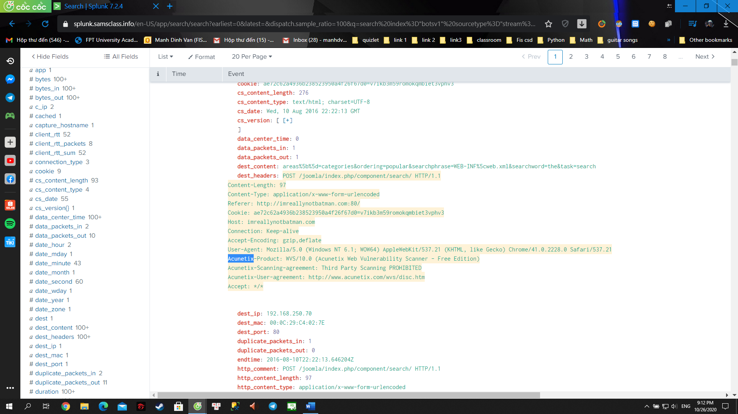

**BOTSv1 1.2**: Attacker IP (5 pts)

Find the attacker's IP address.

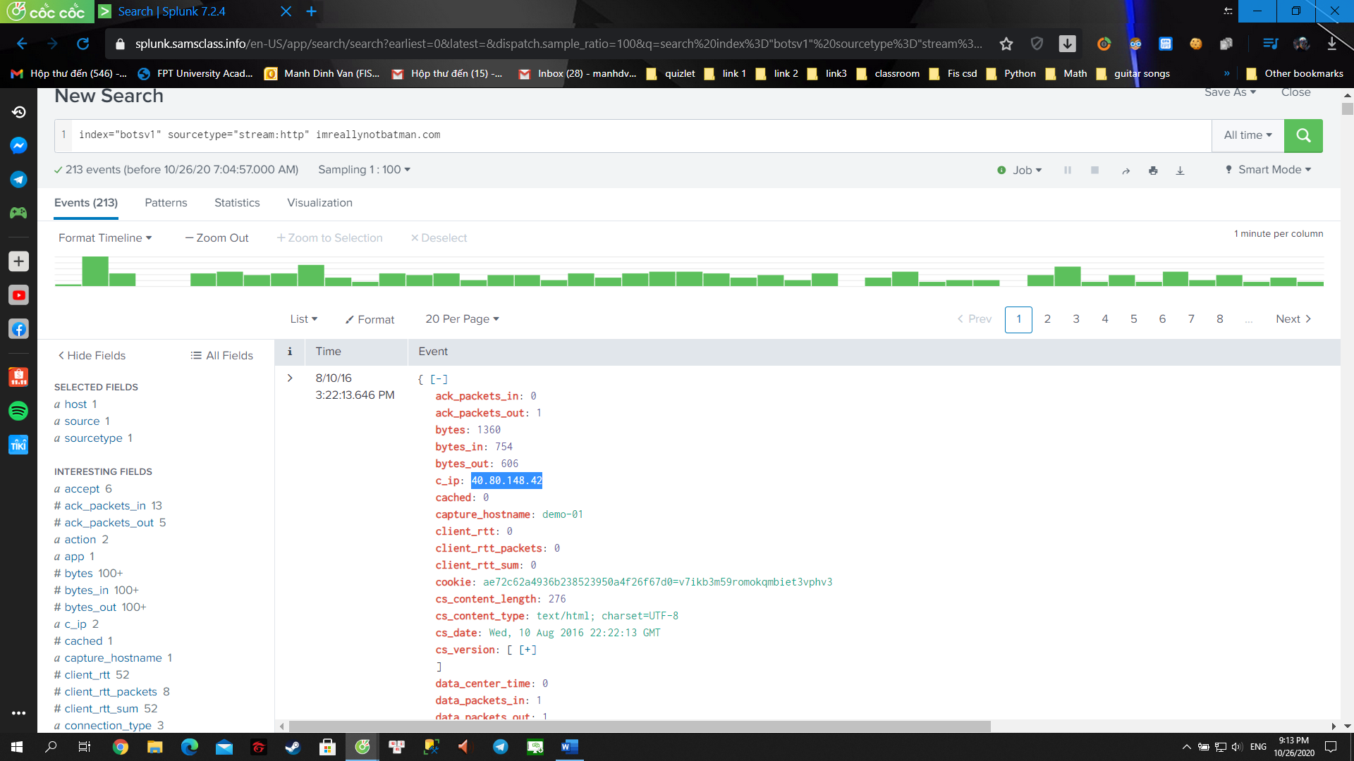

**BOTSv1 1.3**: Web Server IP (5 pts)

Find the IP address of the web server serving "imreallynotbatman.com".

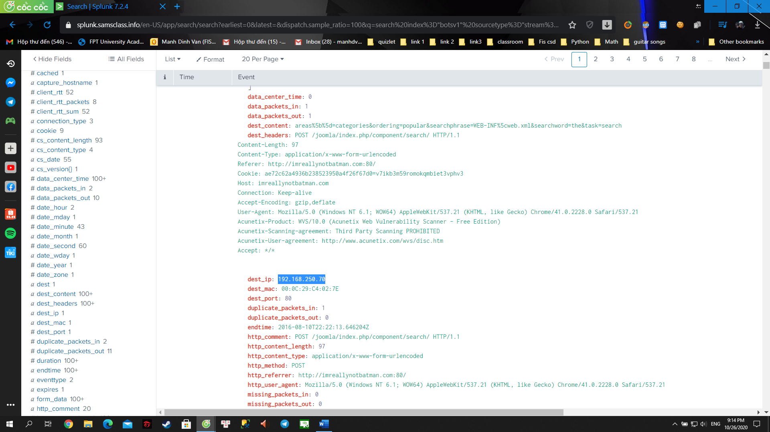

**BOTSv1 1.4**: Defacement Filename (10 pts)

Find the name of the file used to deface the web server serving "imreallynotbatman.com".

Hints:

It was downloaded by the Web server, so the server's IP is a client address, not a destination address.

Remove the filter to see all 9 such events. Examine the uri values.

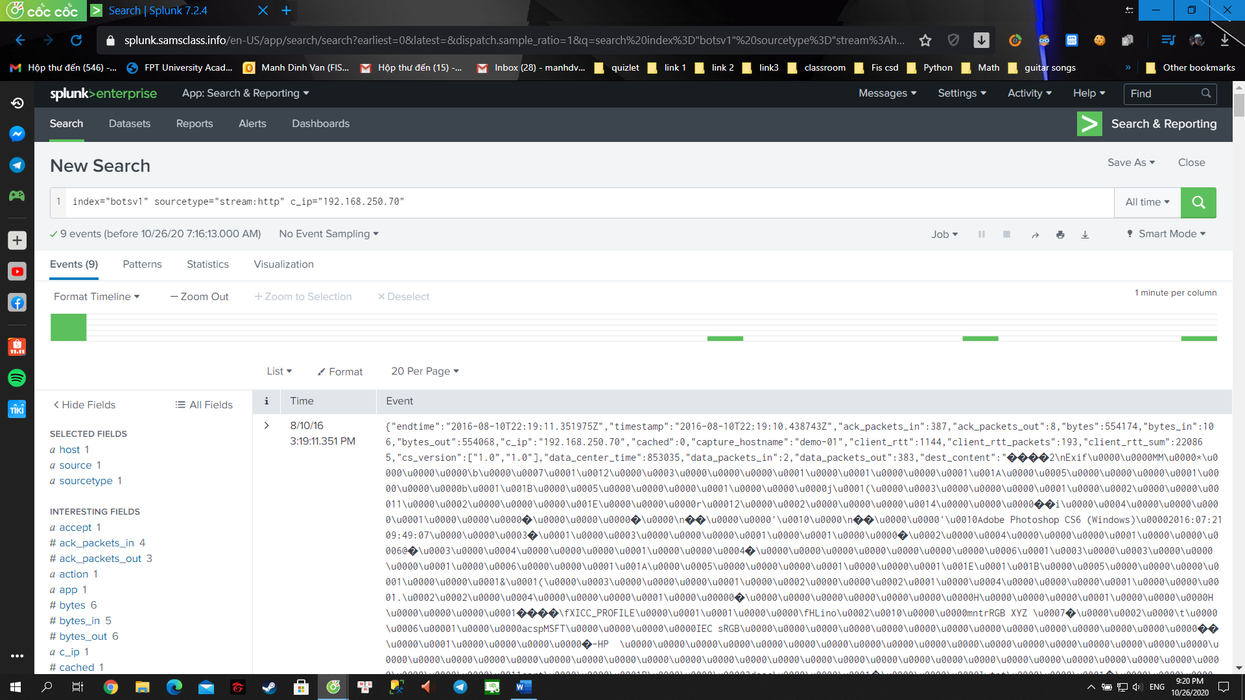

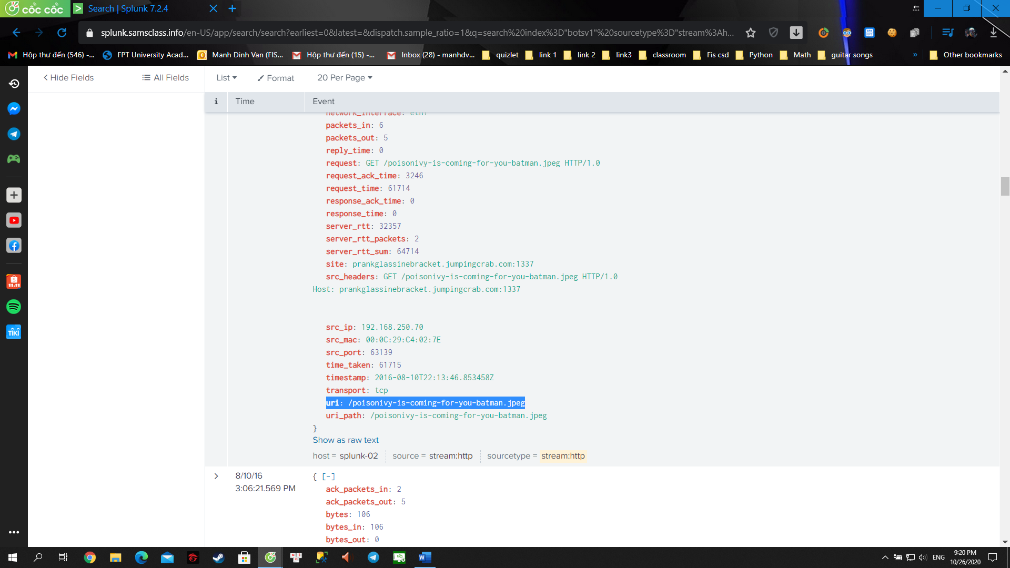

**BOTSv1 1.5**: Domain Name (10 pts)

Find the fully qualified domain name (FQDN) used by the staging server hosting the defacement file.

Hints:

Examine the 9 events from the previous challenge. Look at the url values.

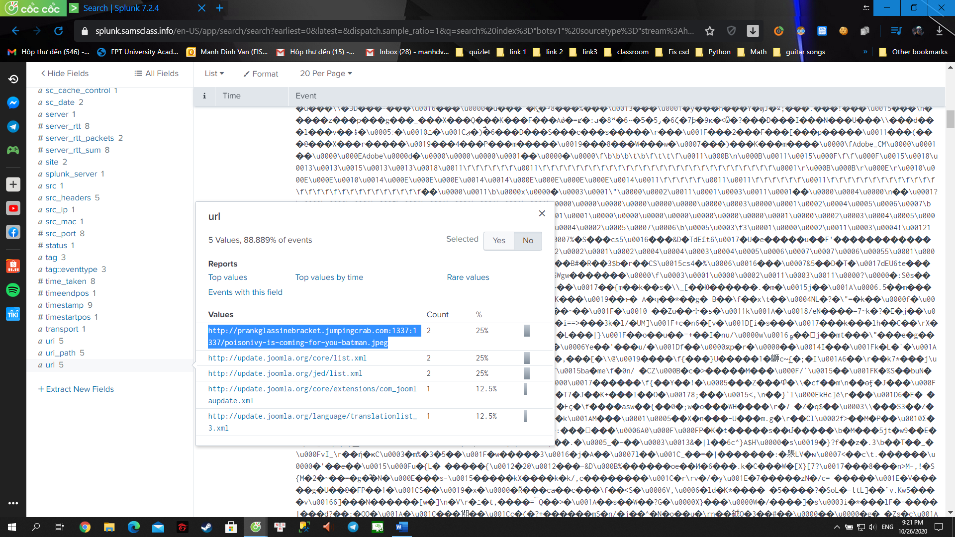

Answers: prankglassinebracket.jumpingcrab.com:1337

**Questions 7**: What IP address has Po1s0n1vy tied to domains that are pre-staged to attack Wayne Enterprises?

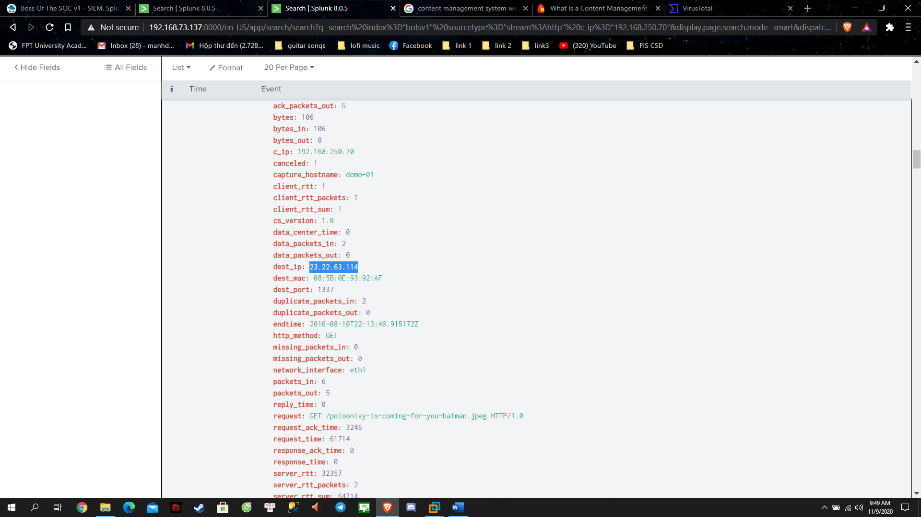

Answer: 23.22.63.114

**Questions 8**: Based on the data gathered from this attack and common open source intelligence sources for domain names, what is the email address that is most likely associated with Po1s0n1vy APT group?

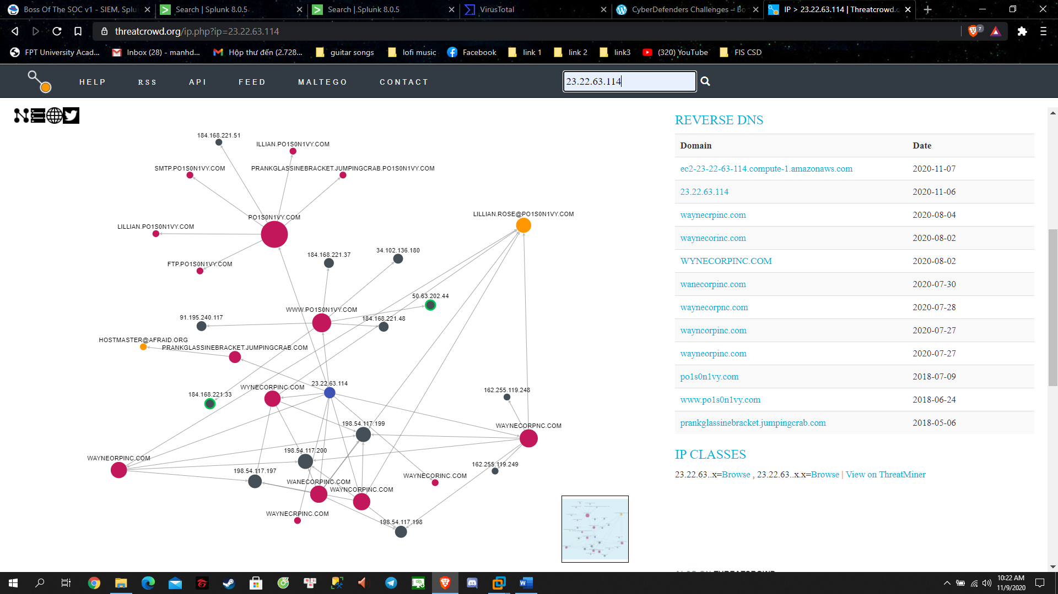

Answers: [LILLIAN.ROSE@PO1S0N1VY.COM](mailto:LILLIAN.ROSE@PO1S0N1VY.COM)

**Question 9**: What IP address is likely attempting a brute force password attack against imreallynotbatman.com?

- The hacker is attempting to brute force password against imreallynotbatman.com website which mean the hacker have to post the brute force password to the website

=> So adding http_method=POST field to our search

- First is catching the password log by finding any matching string “*passwd=*” (I tried password but didn’t get any result, the same with pass)

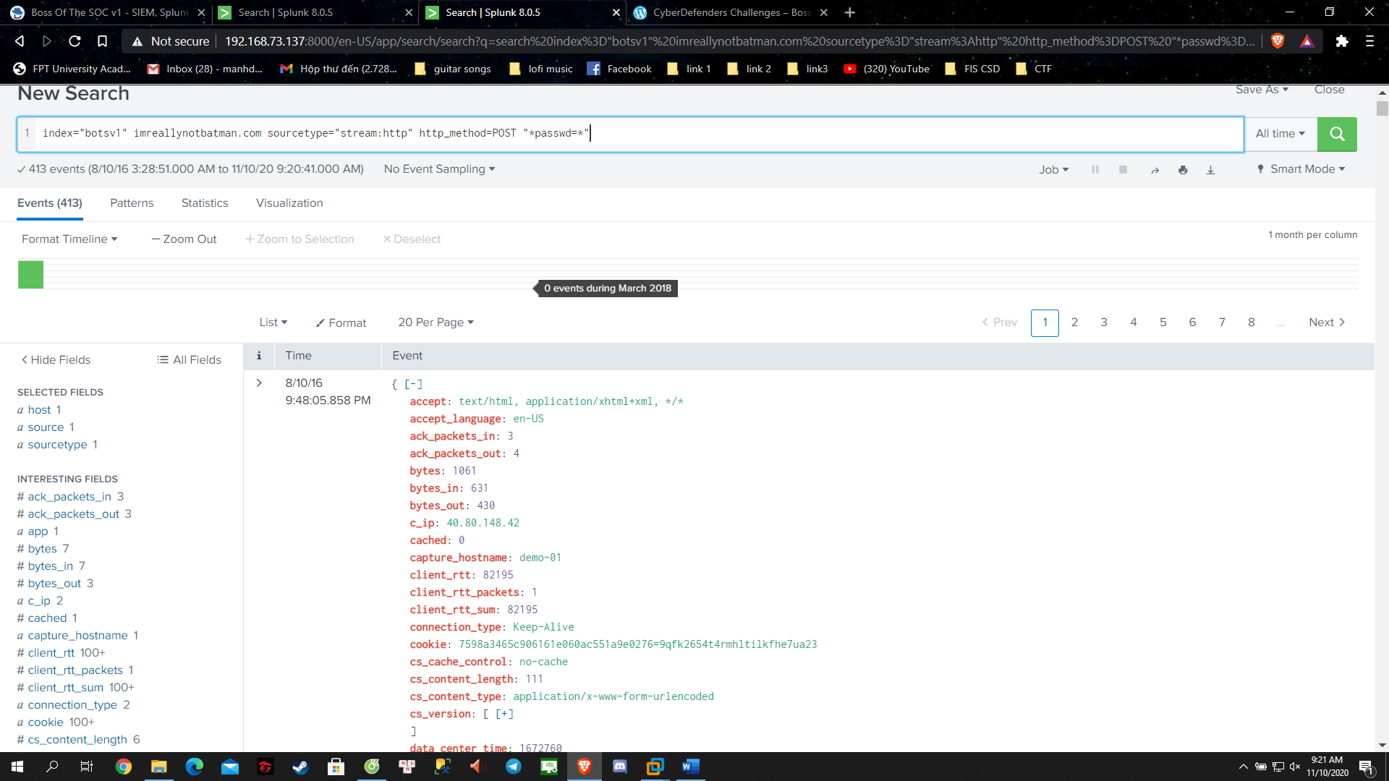

- Now we need to sort this out to look up more easily

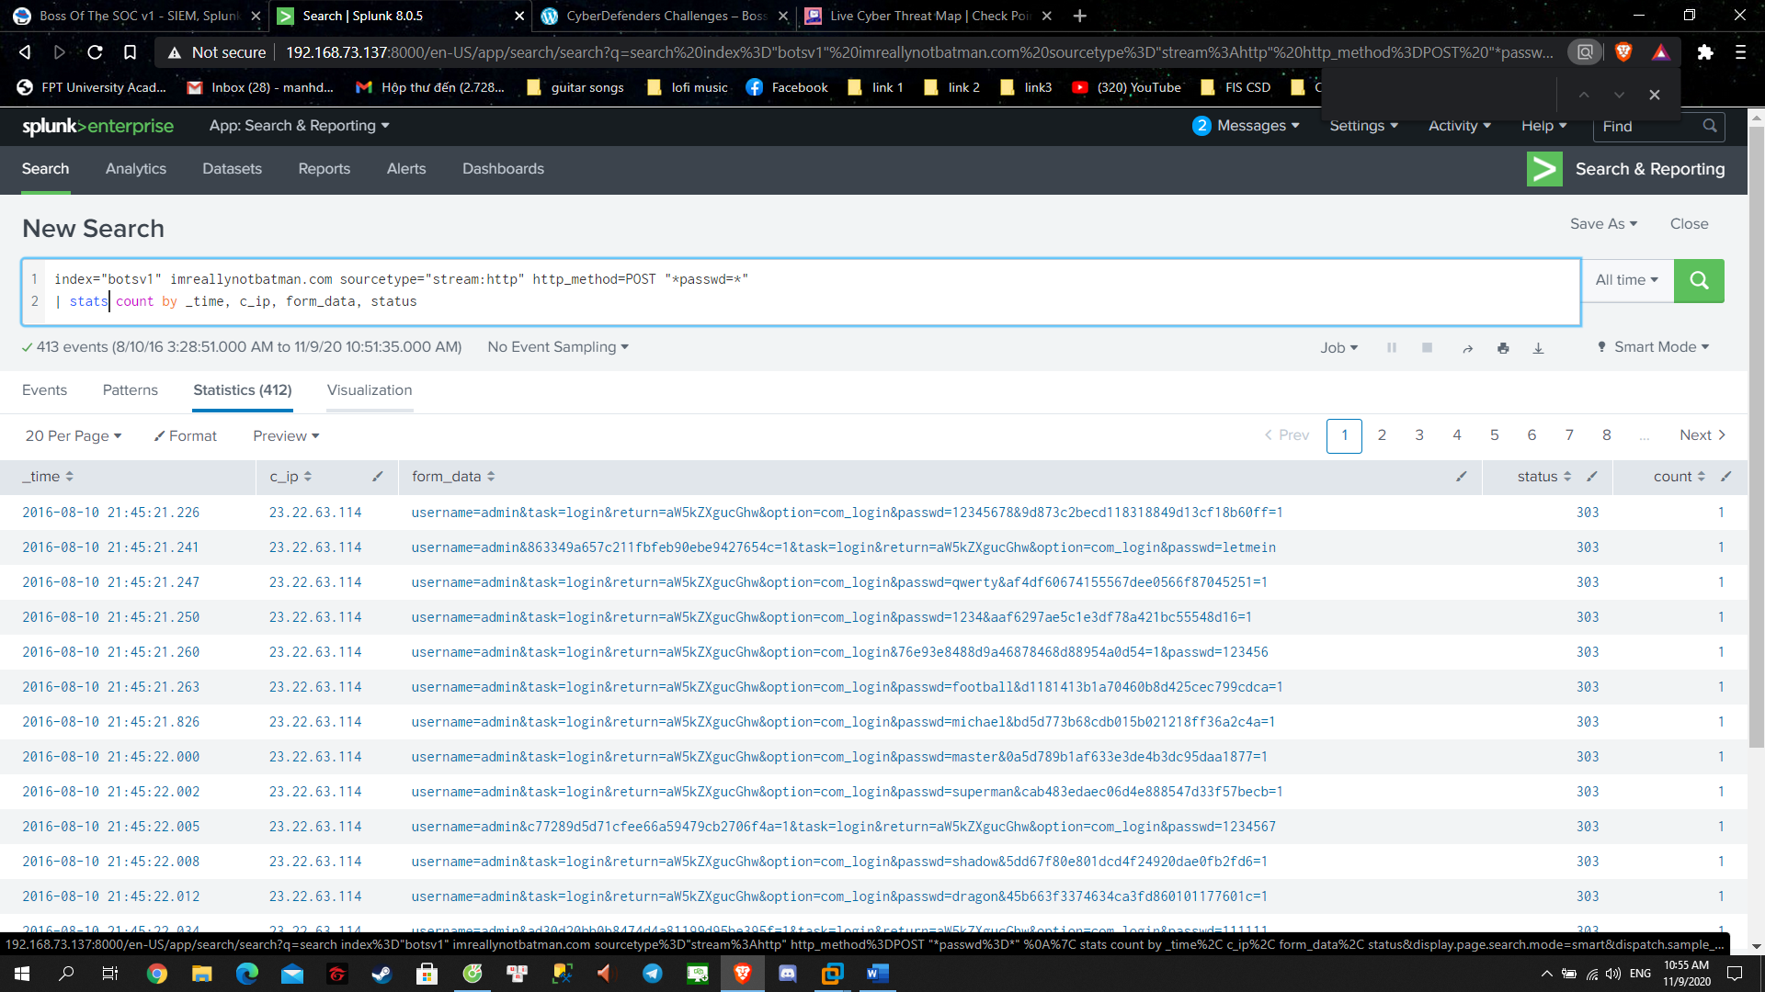

- We want to see the first post one so sort the time upward

Answer: 23.22.63.114

**Question 10**: What is the name of the executable uploaded by Po1s0n1vy? Please include file extension. (For example, "notepad.exe" or "favicon.ico")

- Since Po1s0n1vy is uploading an executable file so I guess she is posting it. Which mean we still search in the http:stream log and method is POST

- Taking from the basic, when POST something, the data that forms the body of the request will be encoded in some way

+ HTML forms provide three methods of encoding:

- application/x-www-form-urlencoded (the default)

- multipart/form-data

- text/plain

- So our attention here is “ multipart/form-data “ is used when we want to include any <input type="file"> elements in it

+ application/x-www-form-urlencoded is more or less the same as a query string on the end of the URL.

+ multipart/form-data is significantly more complicated but it allows entire files to be included in the data

- So now we got our target for searching, let’s make a query:

+ Remember no event sampling and is ALL TIME

sourcetype="stream:http" http_method=POST "multipart/form-data"

- This will return 3 result but just taking a look at the first one and loop up in it and catch it

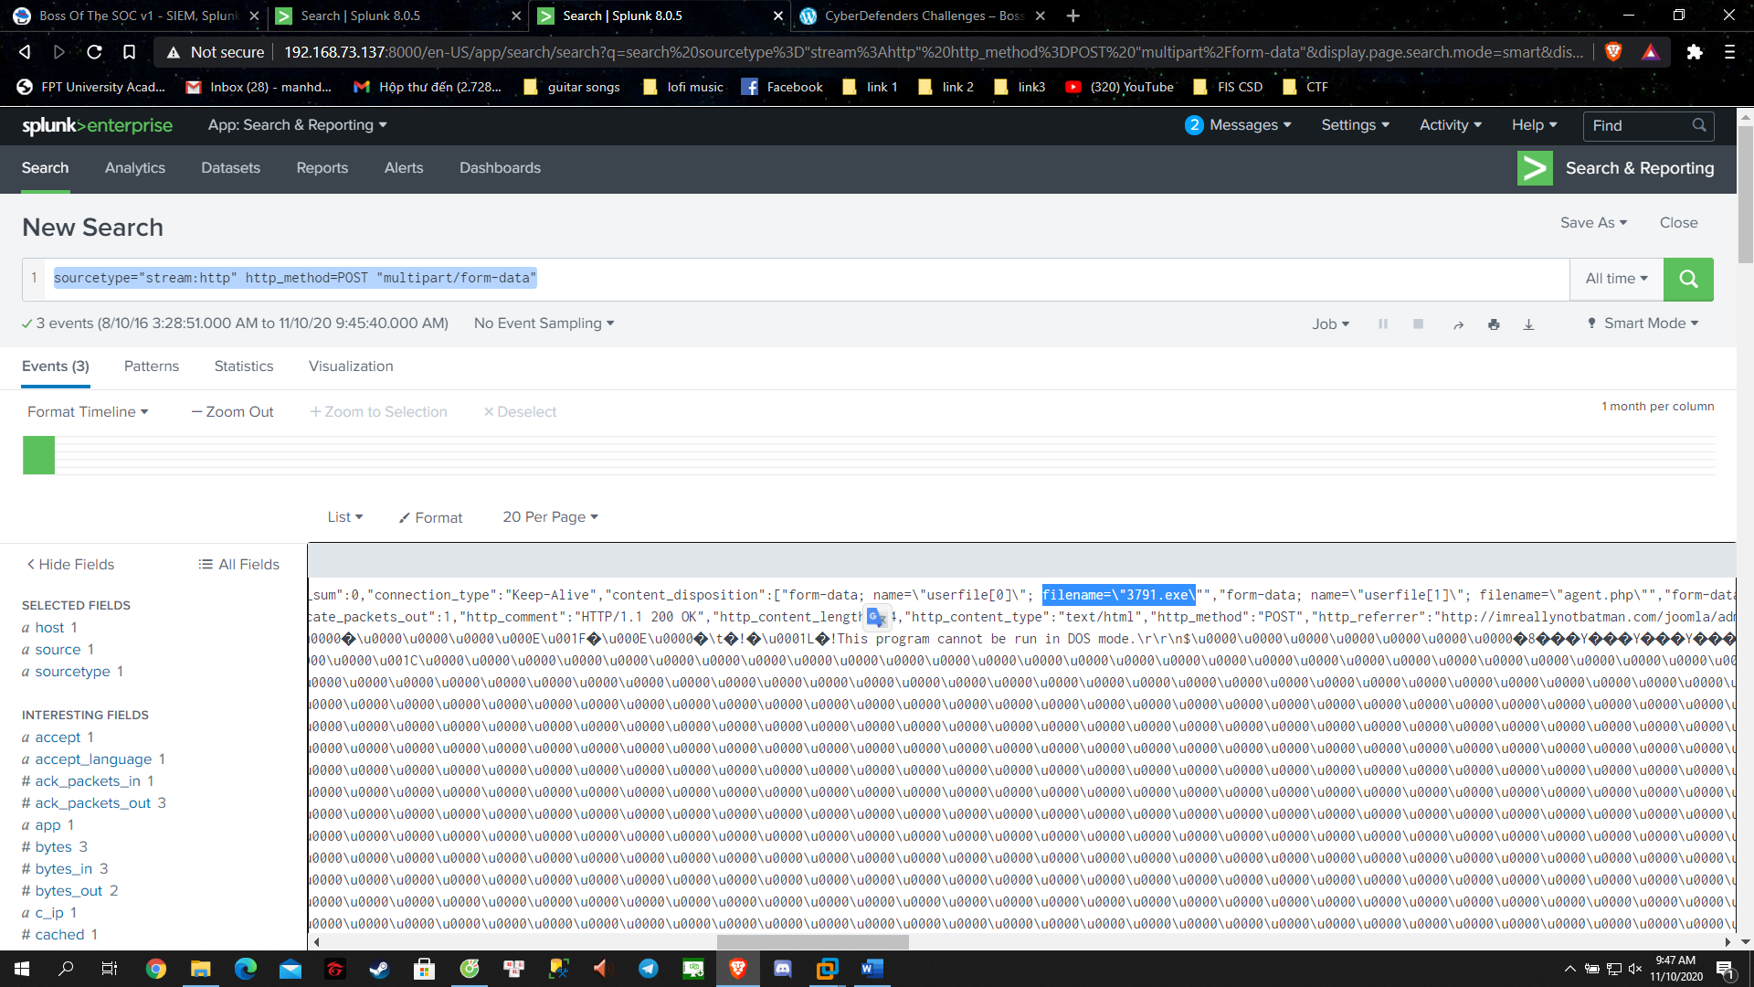

Answer: 3791.exe

**Question 11**: What is the MD5 hash of the executable uploaded?

- Reading Microsoft doc told us that the log Sysmon will records the hash of the process

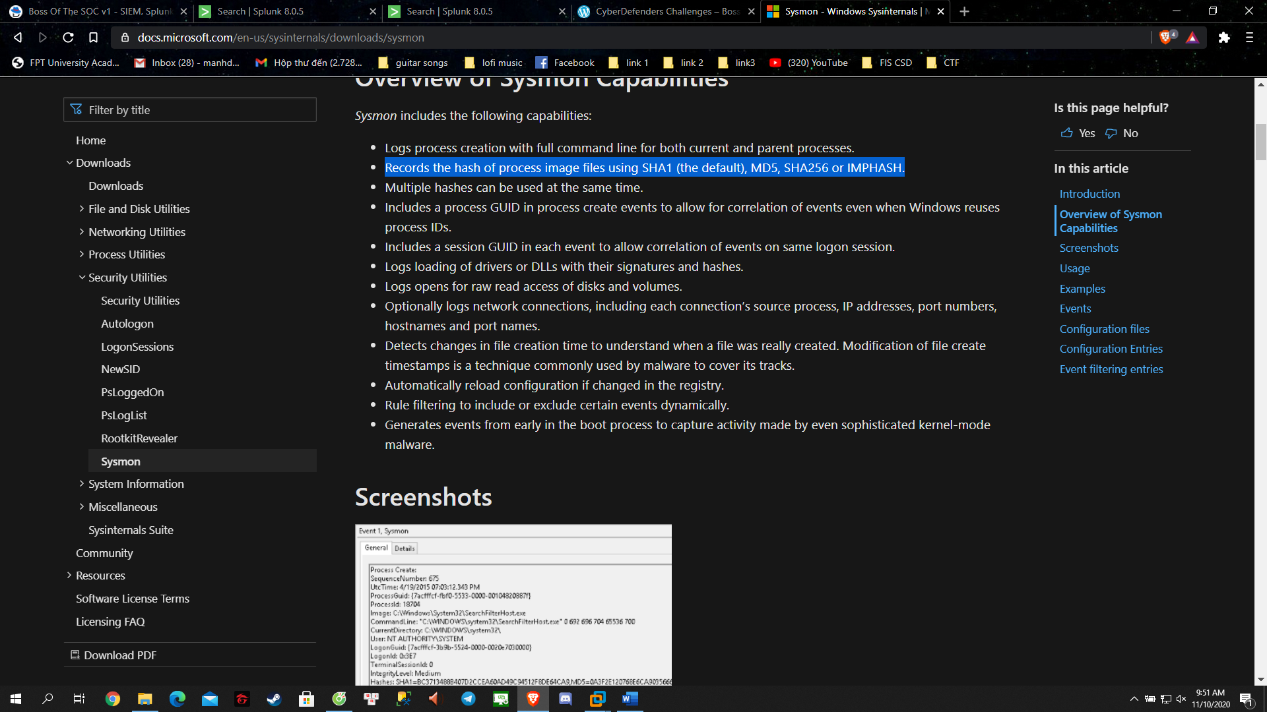

- So now we will try to look up and see what we got :

index=* sourcetype="xmlwineventlog:microsoft-windows-sysmon/operational" 3791.exe

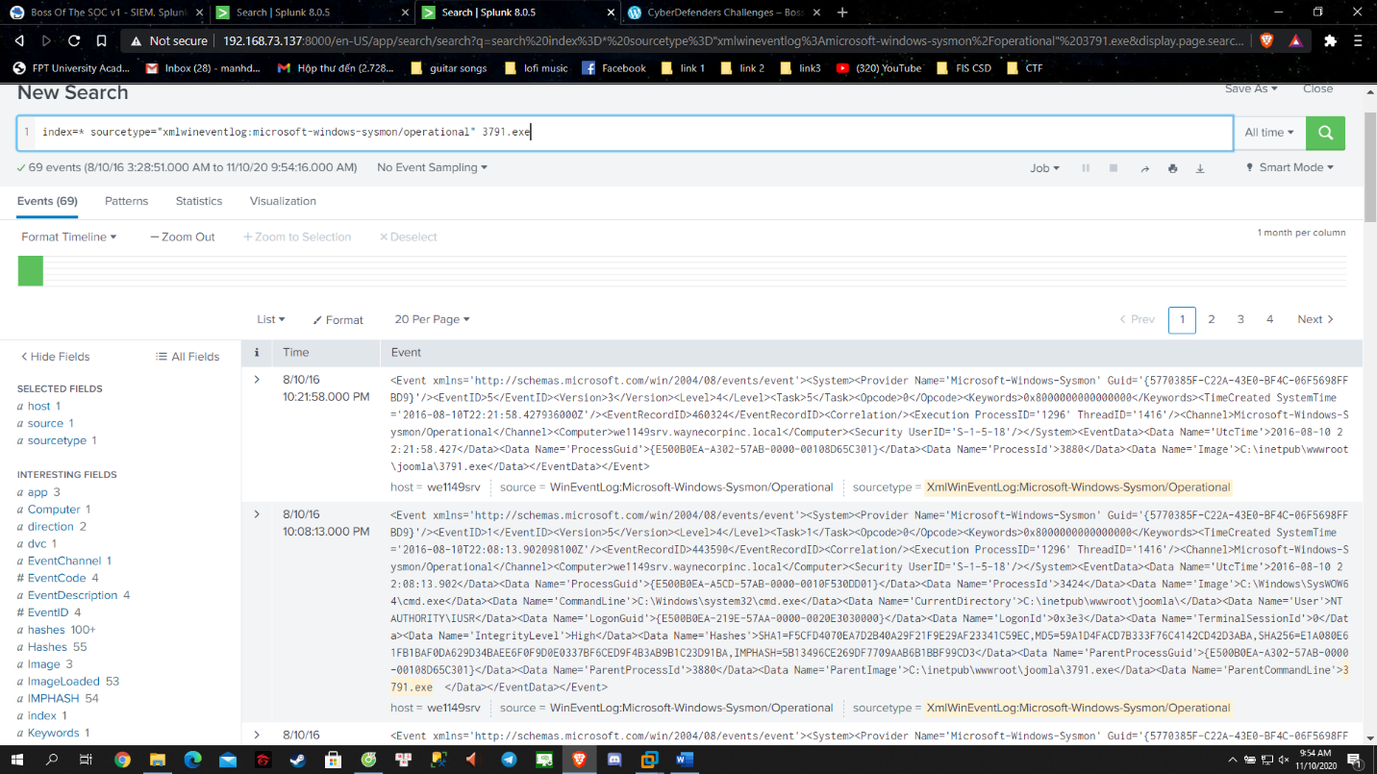

- So far we got 69 results… Let’s see

- Remember the doc : “Record the hash of process image file …” so I look into ImageLoaded field

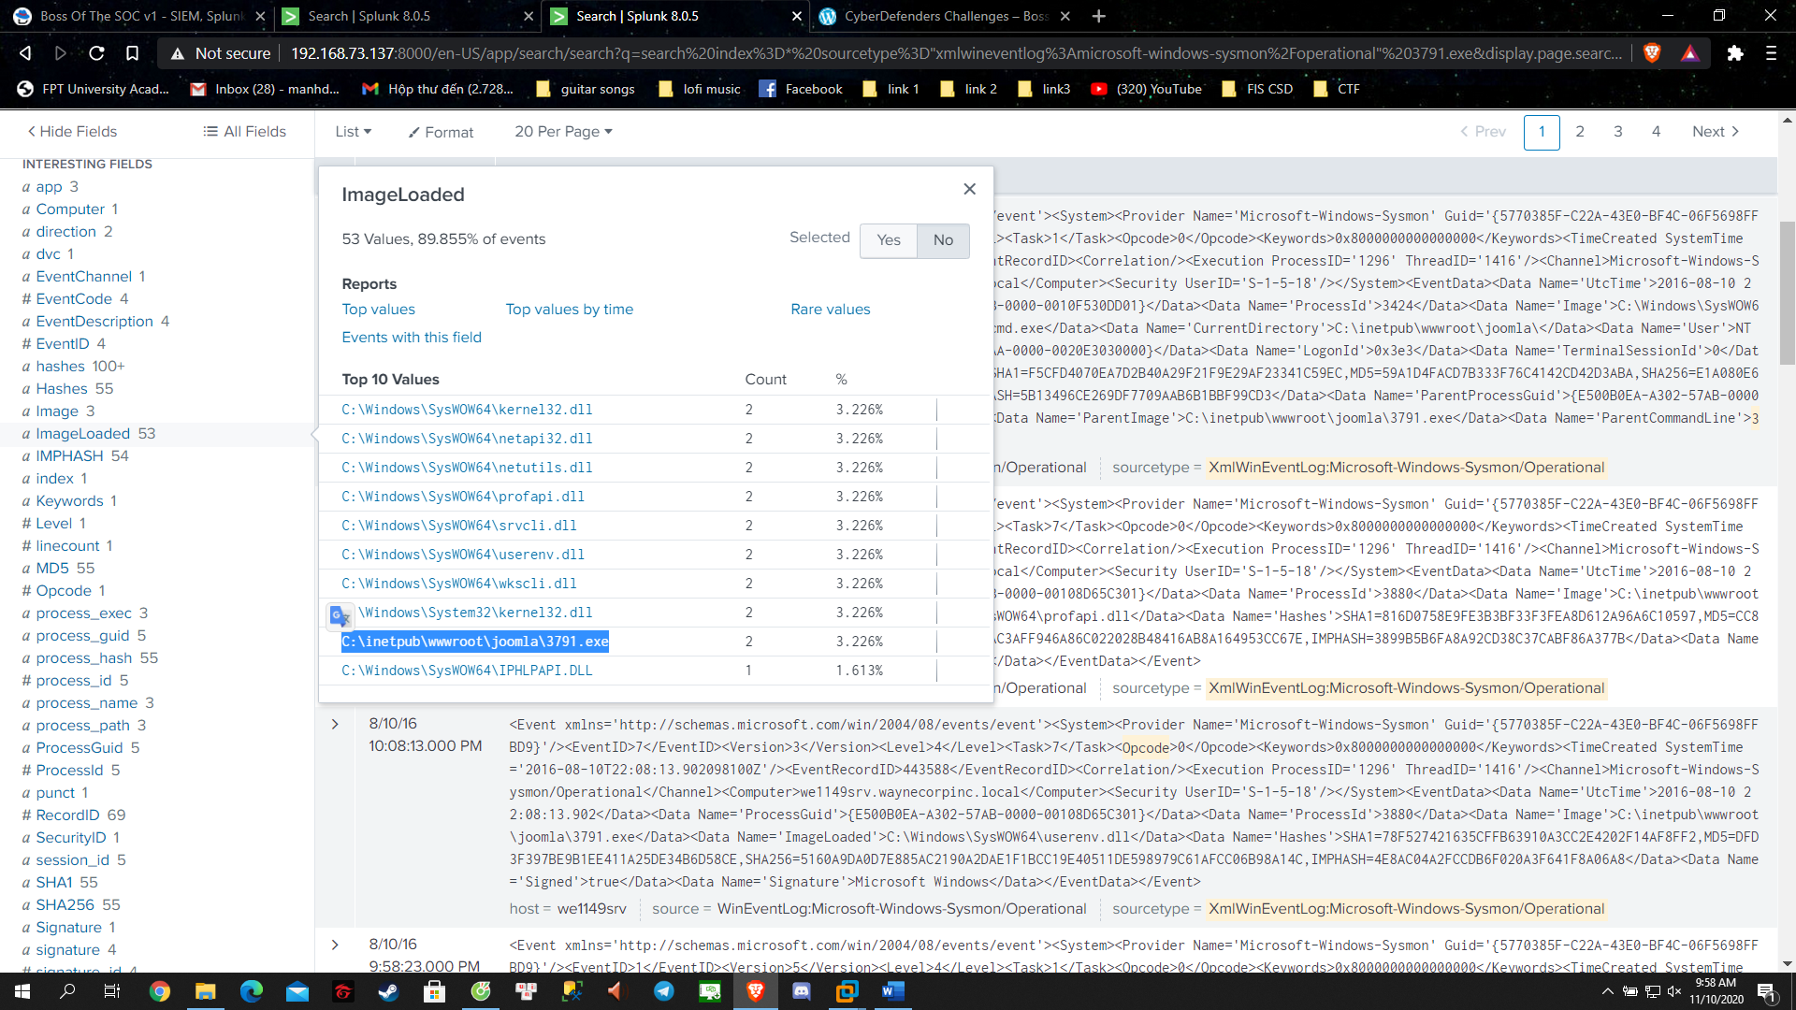

- Got you !!!

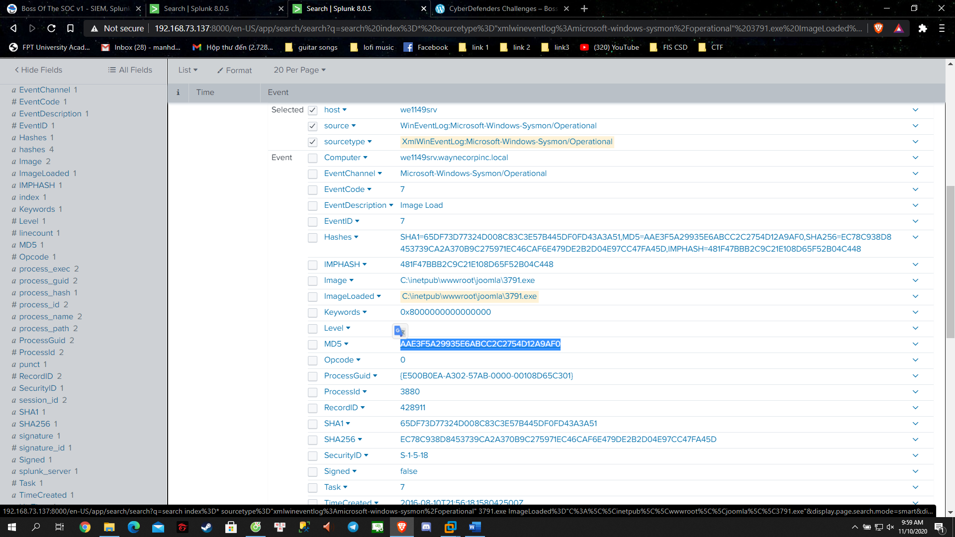

Answers: AAE3F5A29935E6ABCC2C2754D12A9AF0

**Questions 12**: GCPD reported that common TTPs (Tactics, Techniques, Procedures) for the Po1s0n1vy APT group, if initial compromise fails, is to send a spear phishing email with custom malware attached to their intended target. This malware is usually connected to Po1s0n1vys initial attack infrastructure. Using research techniques, provide the SHA256 hash of this malware.

- Ok we are provided with the next scenario about Po1s0n1vy’s plan B (lmao). So we are looking for a malware

- “This malware is usually connected to Po1s0n1vys initial attack infrastructure ”: look back at question 7 so I guess the malware is sent from this ip

- OK, lets ask VirusTotal:

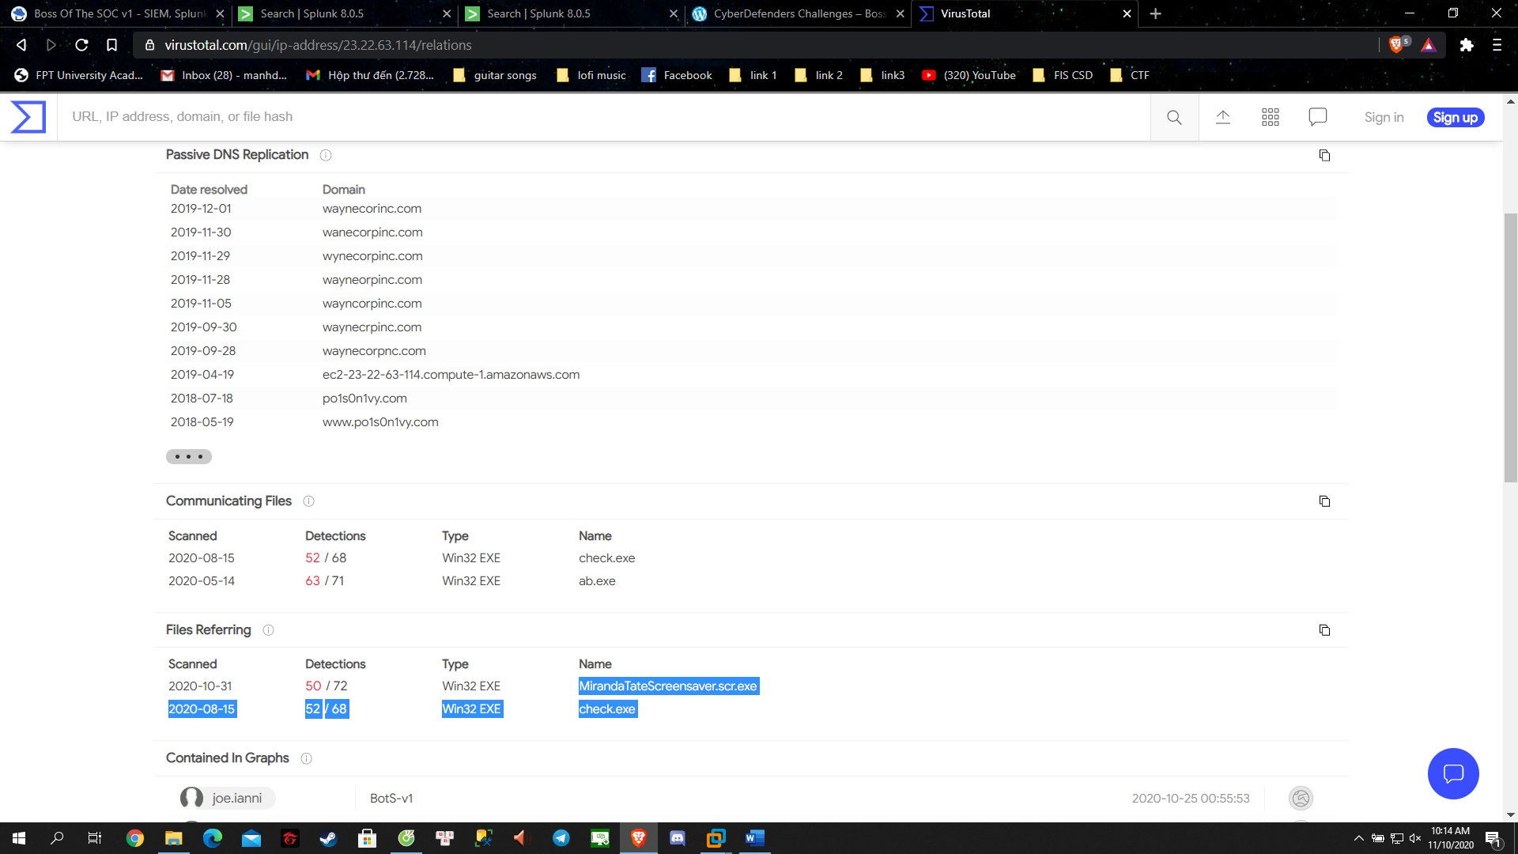

So I try both and it turned to be MirandaTateScreensaver.scr.exe

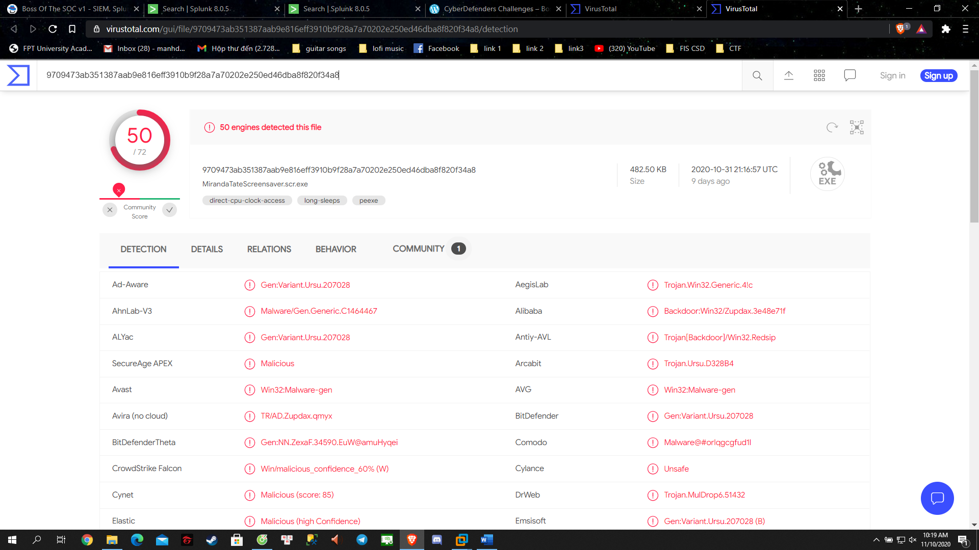

- Answer: 9709473ab351387aab9e816eff3910b9f28a7a70202e250ed46dba8f820f34a8

**Question 13**: What special hex code is associated with the customized malware discussed in question 12? (Hint: It's not in Splunk)

- Good thing I check all tabs xD

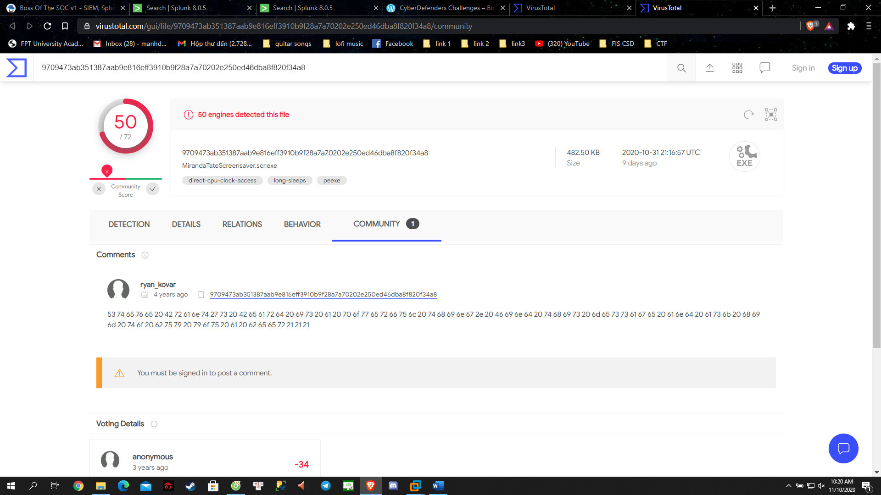

Answer: 53 74 65 76 65 20 42 72 61 6e 74 27 73 20 42 65 61 72 64 20 69 73 20 61 20 70 6f 77 65 72 66 75 6c 20 74 68 69 6e 67 2e 20 46 69 6e 64 20 74 68 69 73 20 6d 65 73 73 61 67 65 20 61 6e 64 20 61 73 6b 20 68 69 6d 20 74 6f 20 62 75 79 20 79 6f 75 20 61 20 62 65 65 72 21 21 21

**Question 15**: What was the first brute force password used?

- We just need to roll back the search and look at the form data field

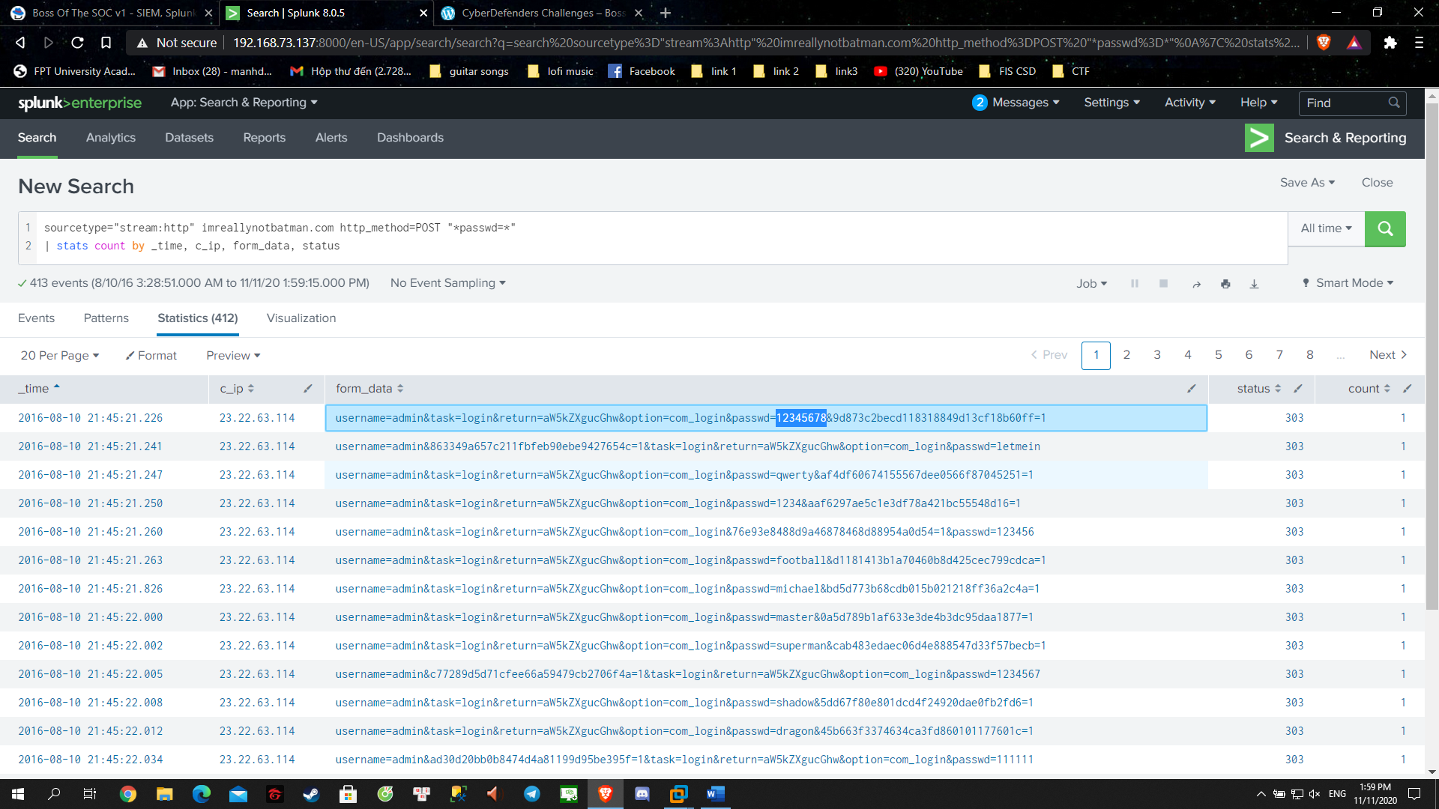

Answer: 12345678

**Question 16**: One of the passwords in the brute force attack is James Brodsky's favorite Coldplay song. Hint: we are looking for a six characters word on this one. Which is it?

- So we might want to extract the password out of the form_data

+ rex "passwd=(?<passwd>[^&\"]+)[\"&]"

+ eval passwd_length = len(passwd)

+ search passwd_length=6

+ stats count by passwd

- Got the result but we still need to check with Coldplay music list:

https://en.wikipedia.org/wiki/List_of_songs_recorded_by_Coldplay

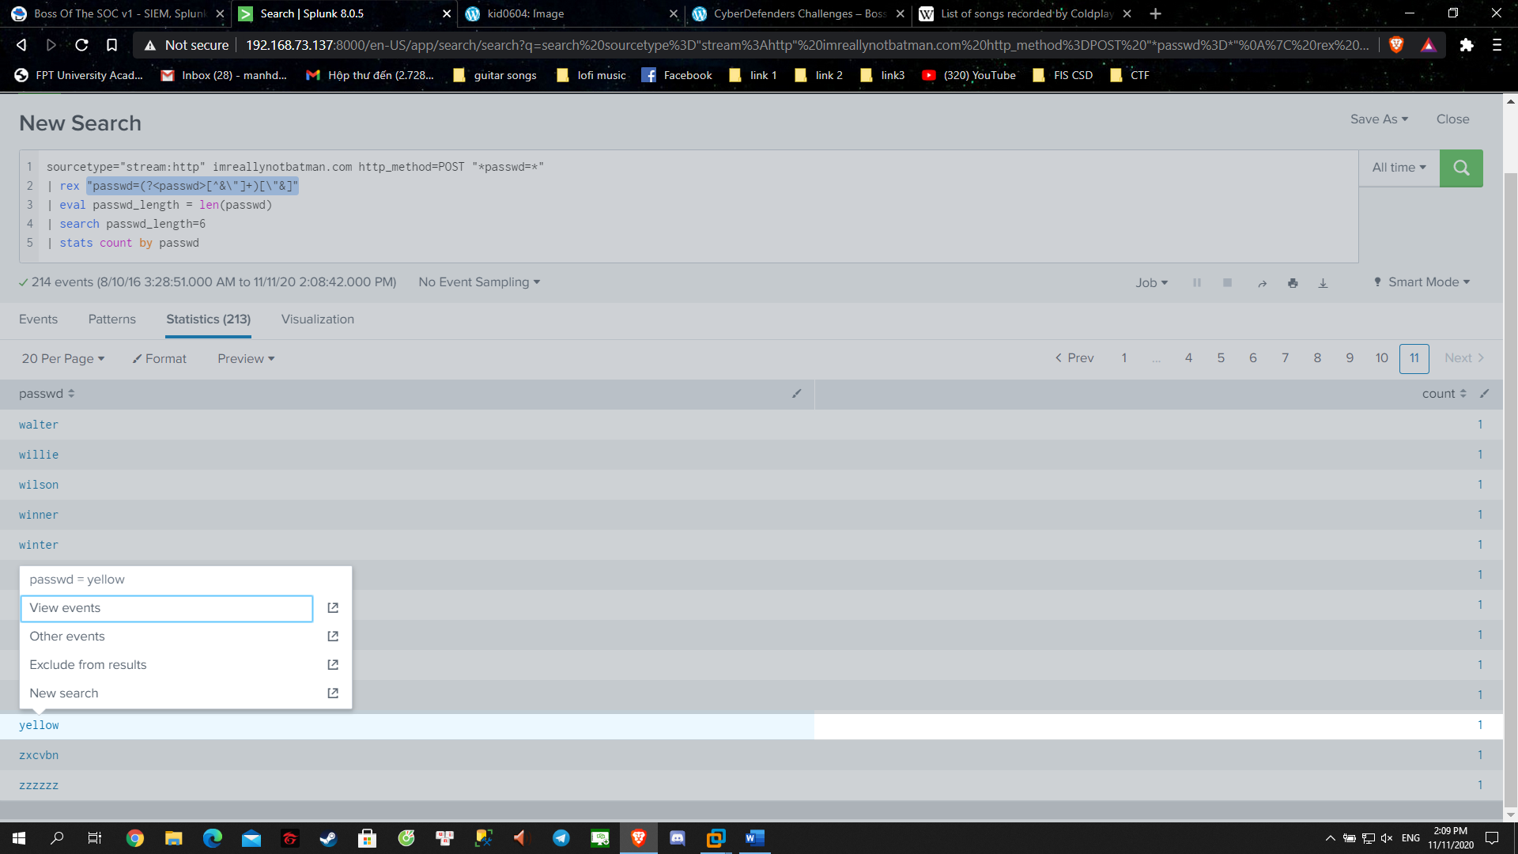

Answer: yellow

**Question 17**: What was the correct password for admin access to the content management system running "imreallynotbatman.com"?

- As we know all the fail attempt to login will just count 1 so we just need to look for the one that appear more than 1

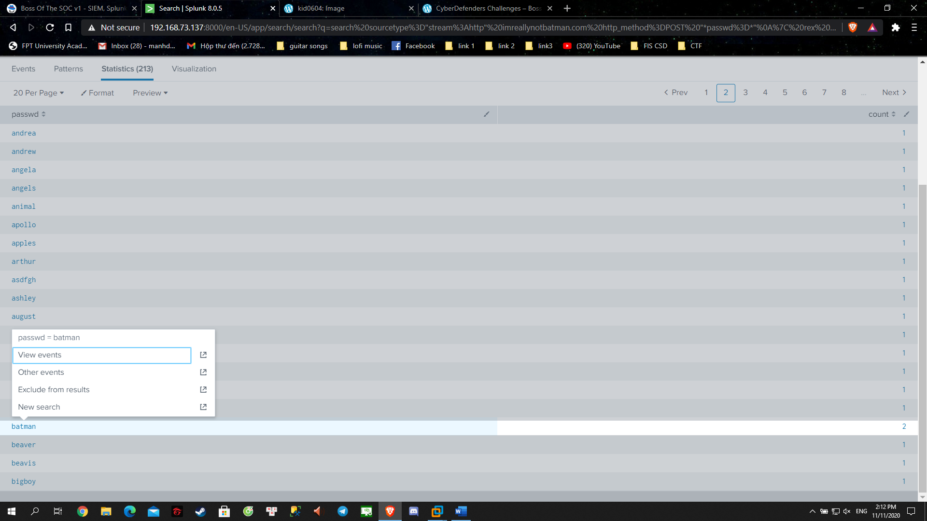

Answer: batman

**Question 18**: What was the average password length used in the password brute forcing attempt? (Round to closest whole integer. For example "5" not "5.23213")

- We are using eventstats to get the avg password length

sourcetype="stream:http" imreallynotbatman.com http_method=POST "*passwd=*"

| rex "passwd=(?<passwd>[^&\"]+)[\"&]"

| eval passwd_length = len(passwd)

| search passwd_length=6

| eventstats avg(passwd_length) as passwd_length

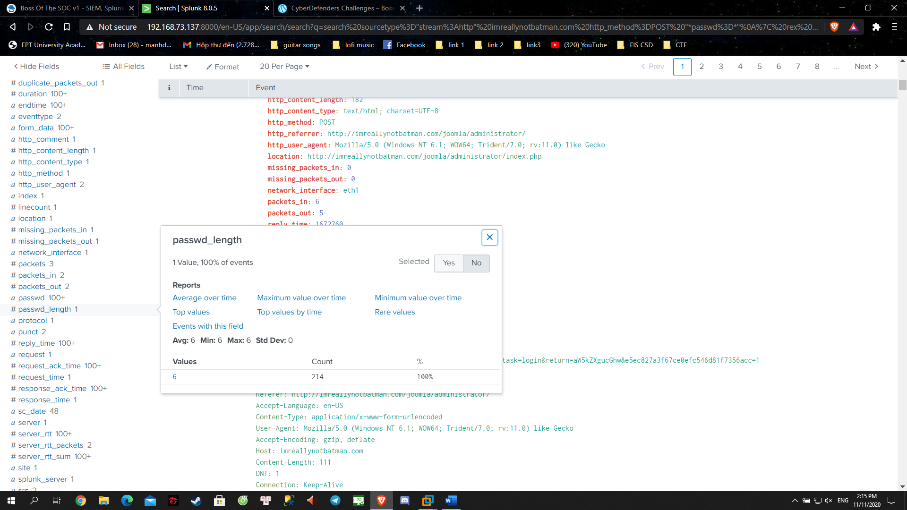

Answer: 6

**Question 19**: How many seconds elapsed between the time the brute force password scan identified the correct password and the compromised login? Round to 2 decimal places.

sourcetype="stream:http" imreallynotbatman.com http_method=POST "*passwd=*"

| rex "passwd=(?<passwd>[^&\"]+)[\"&]"

| eval passwd_length = len(passwd)

| search passwd=batman

| transaction passwd

| table duration

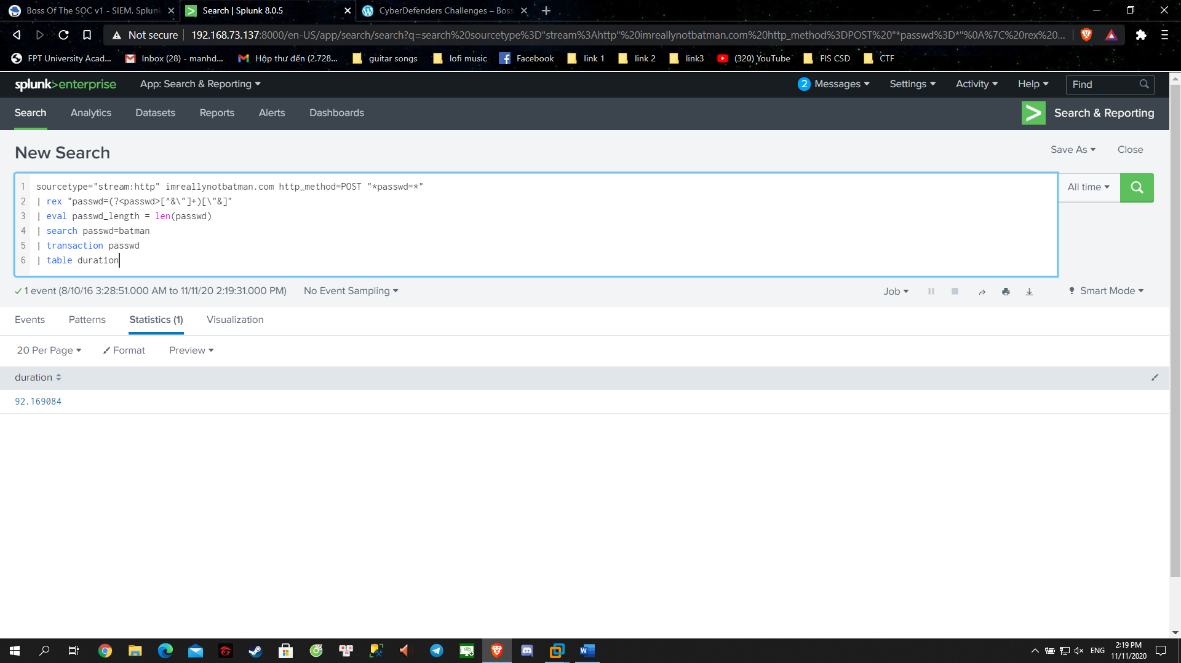

Answer: 92.16

**Question 20**: How many unique passwords were attempted in the brute force attempt?

- This command will count distinct passwd

stats dc(passwd)

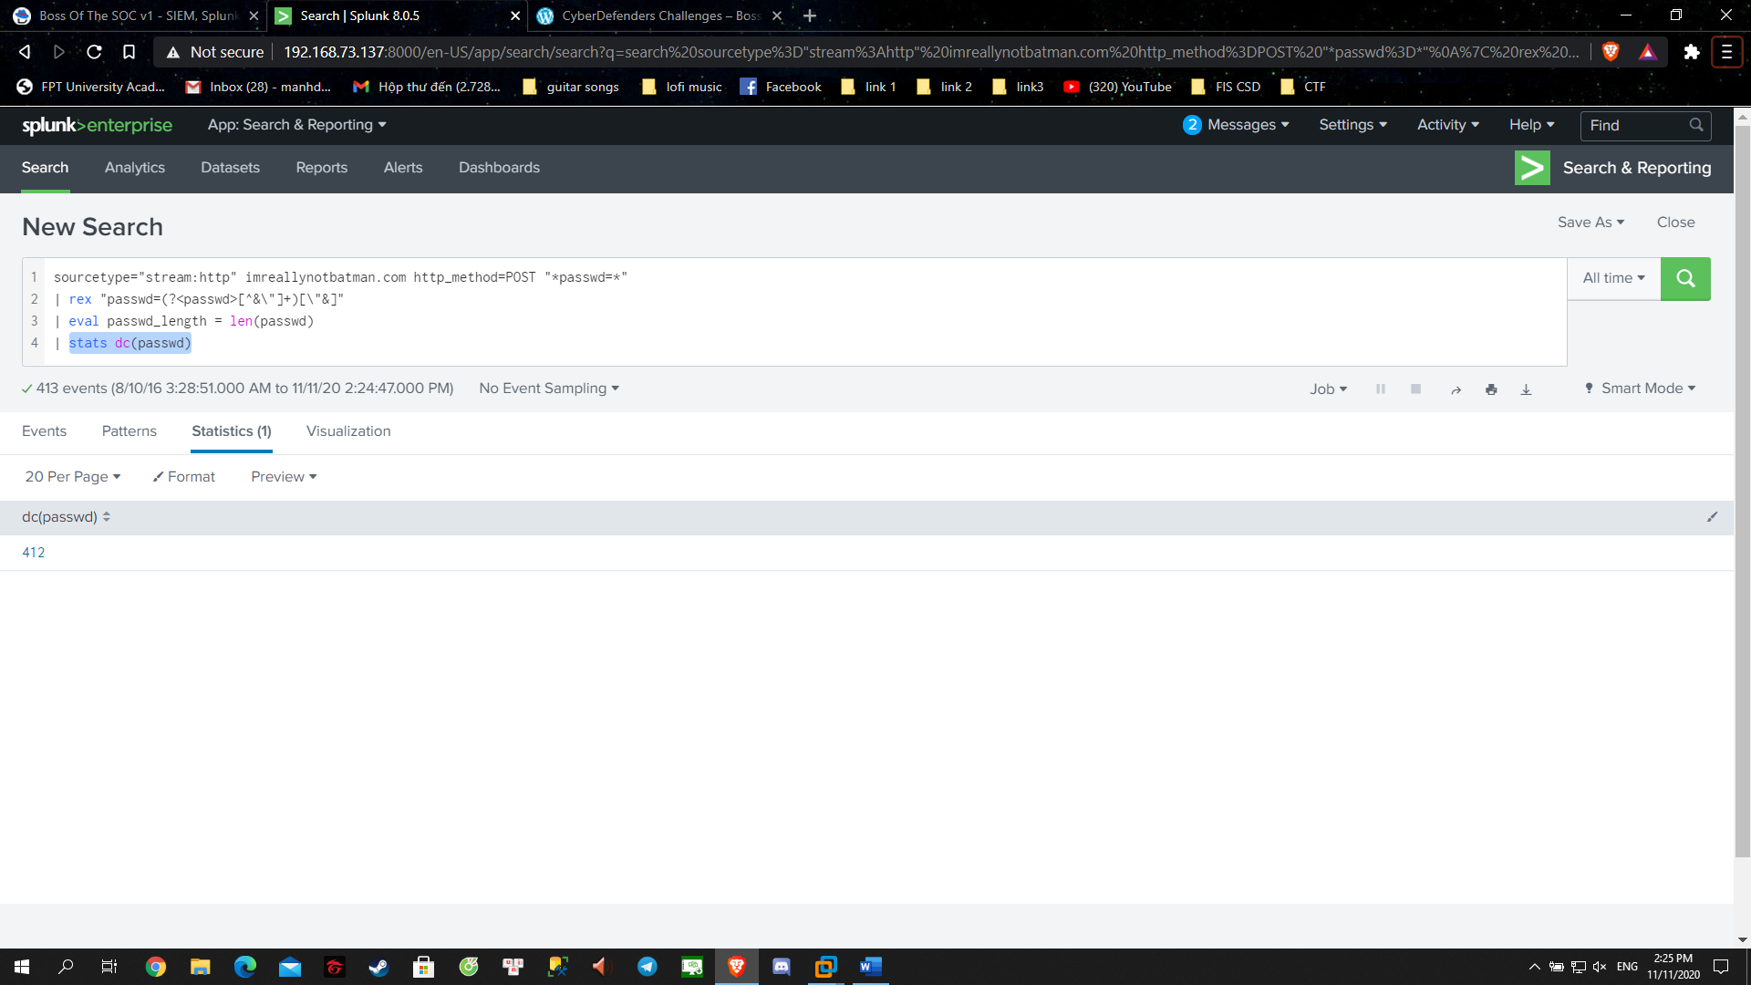

Answer: 412

**Question 21**: What was the most likely IP address of we8105desk on 24AUG2016?

- As we scouting through we this “we8105desk” would locate most, we got: sysmon

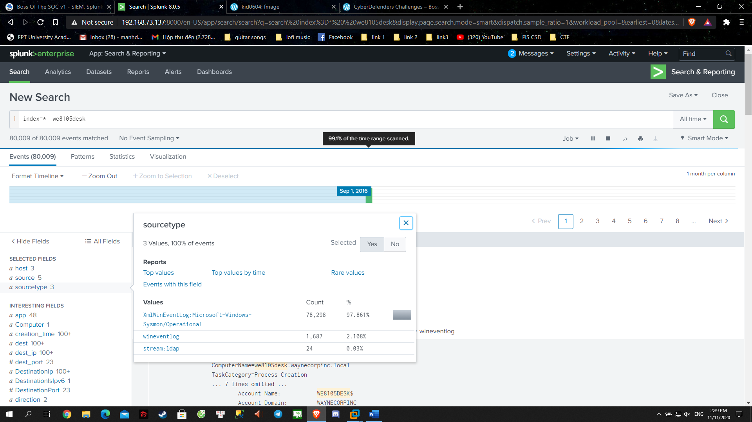

- So our next query would be simple like this:

index=* sourcetype="xmlwineventlog:microsoft-windows-sysmon/operational" we8105desk

- So what we are looking for is the ip address so we might want to take a look at src_ip filed:

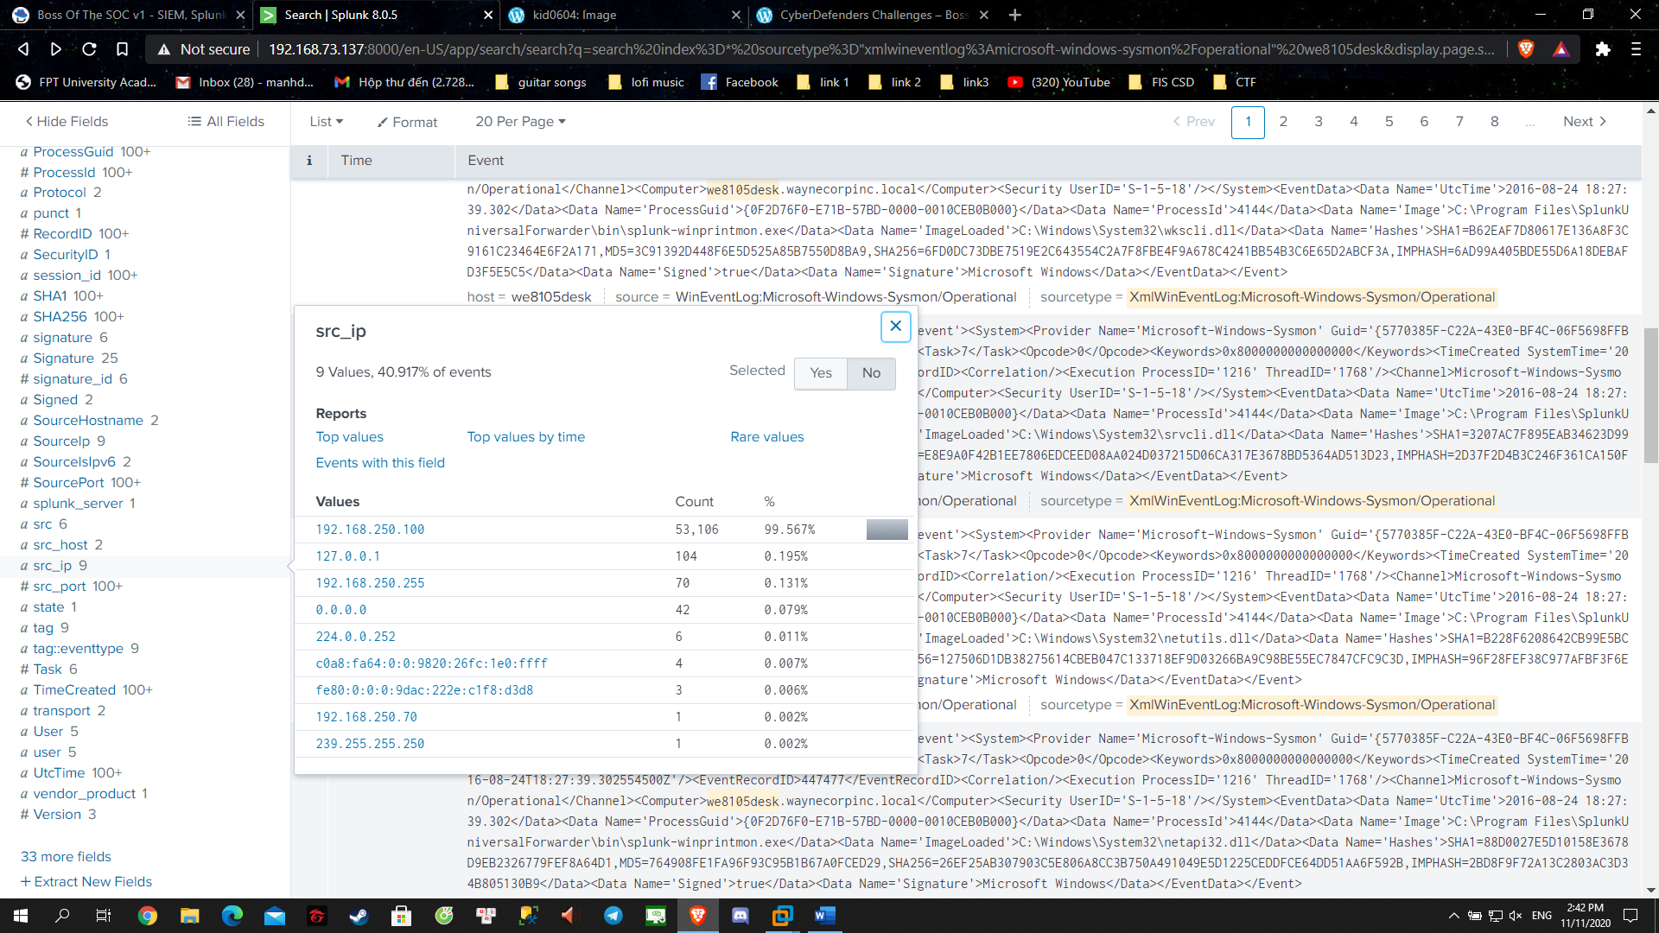

- Seem like we have our catch, and it’s the right one

Answer: 192.168.250.100

**Question 22**: Amongst the Suricata signatures that detected the Cerber malware, which one alerted the fewest number of times? Submit ONLY the signature ID value as the answer. (No punctuation, just 7 integers.)

- From the question we got some hint like:

Source_type=suricata

Event_type=alert

And we looking for Cerber malware

- So our command is:

sourcetype="suricata" event_type=alert *Cerber*

| stats count by alert.signature_id, alert.signature

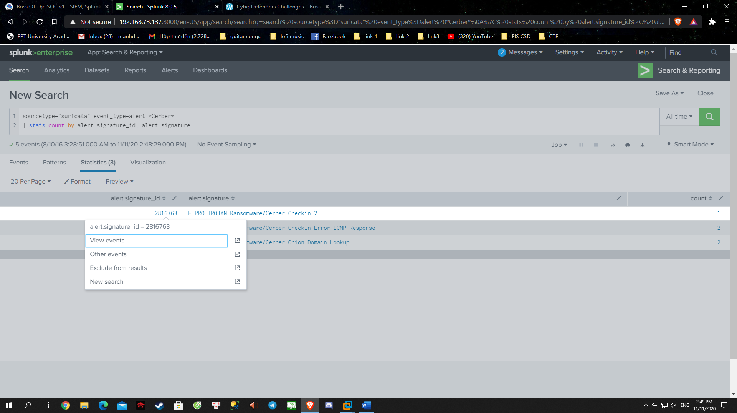

Answer: 2816763

**Question 23**: What fully qualified domain name (FQDN) does the Cerber ransomware attempt to direct the user to at the end of its encryption phase?

- This is pretty much simple since we got the ip is 192.168.250.100 and we are looking for a dns so here is our command :

sourcetype="suricata" event_type=dns *Cerber* src_ip="192.168.250.100"

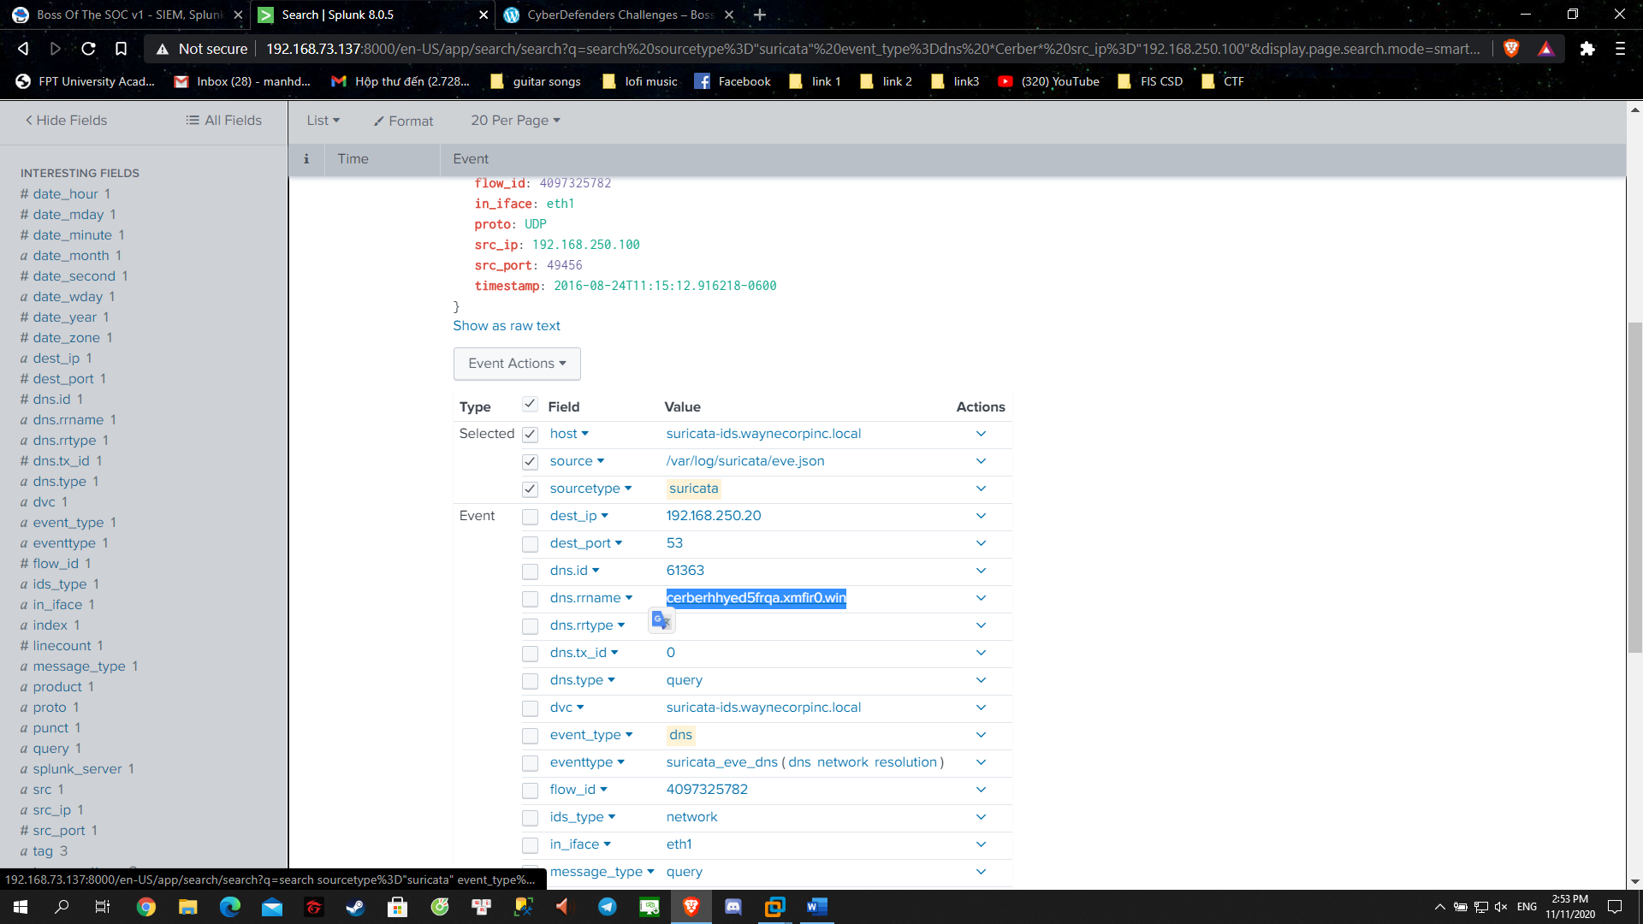

Answer: [cerberhhyed5frqa.xmfir0.win](http://192.168.73.137:8000/en-US/app/search/search?q=search%20sourcetype%3D%22suricata%22%20event_type%3Ddns%20*Cerber*%20src_ip%3D%22192.168.250.100%22&display.page.search.mode=smart&dispatch.sample_ratio=1&workload_pool=&earliest=0&latest=now&display.page.search.tab=events&display.general.type=events&sid=1605106303.183)

**Question 24**: What was the first suspicious domain visited by we8105desk on 24AUG2016?

- My first try and I got this: 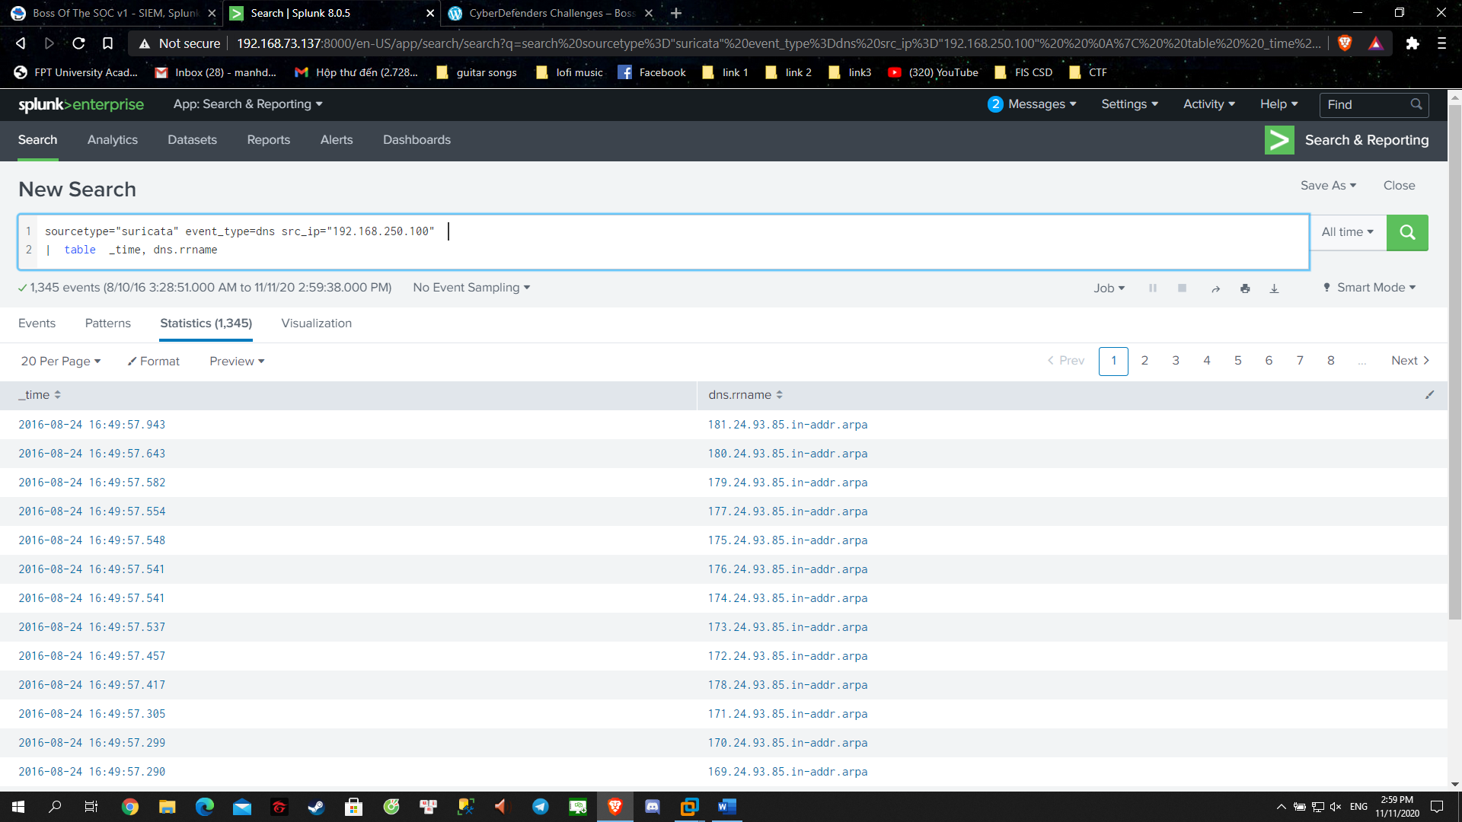

- We might want to exclude those out:

sourcetype="suricata" event_type=dns src_ip="192.168.250.100" "dns.rrname"!="*.in-addr.arpa"

| table _time, dns.rrname

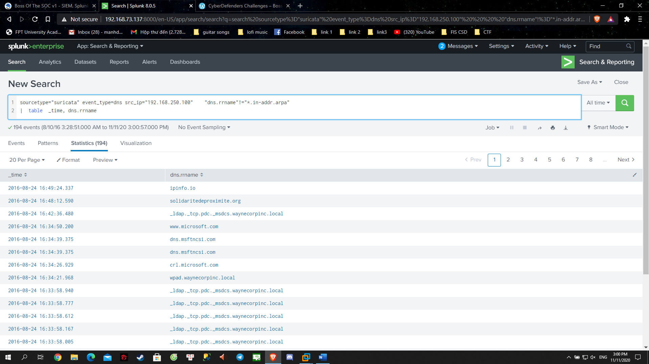

- Let’s check the first few one:

When I check solidaritedeproximite.org on virustotal and I got this:

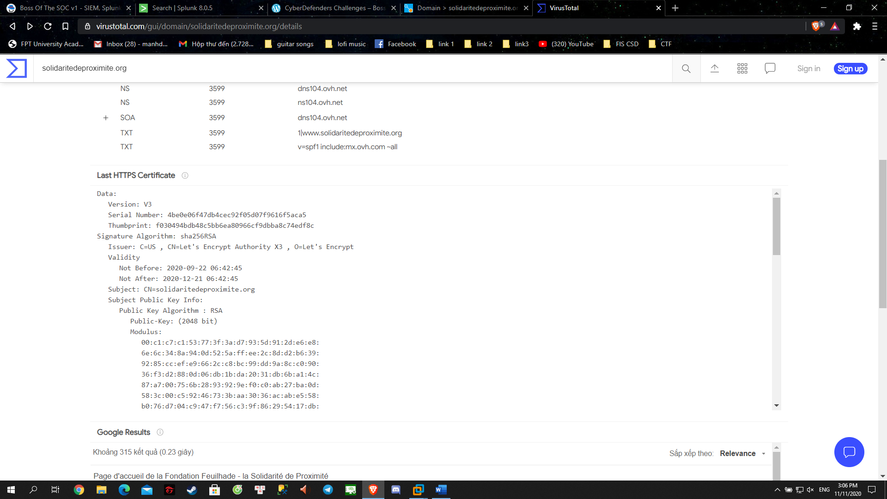

- So we already know that the malware is ransomware so it is like do cryptography

- I try this and it’s correct …

Answers: solidaritedeproximite.org.

**Question 25**: During the initial Cerber infection a VB script is run. The entire script from this execution, pre-pended by the name of the launching .exe, can be found in a field in Splunk. What is the length in characters of the value of this field?

- So we are looking for a vb script and .exe, it’s likely to be log Sysmon:

index=* "*.vbs*" sourcetype="XmlWinEventLog:Microsoft-Windows-Sysmon/Operational"

- Looking at the cmdline @@, that IS long

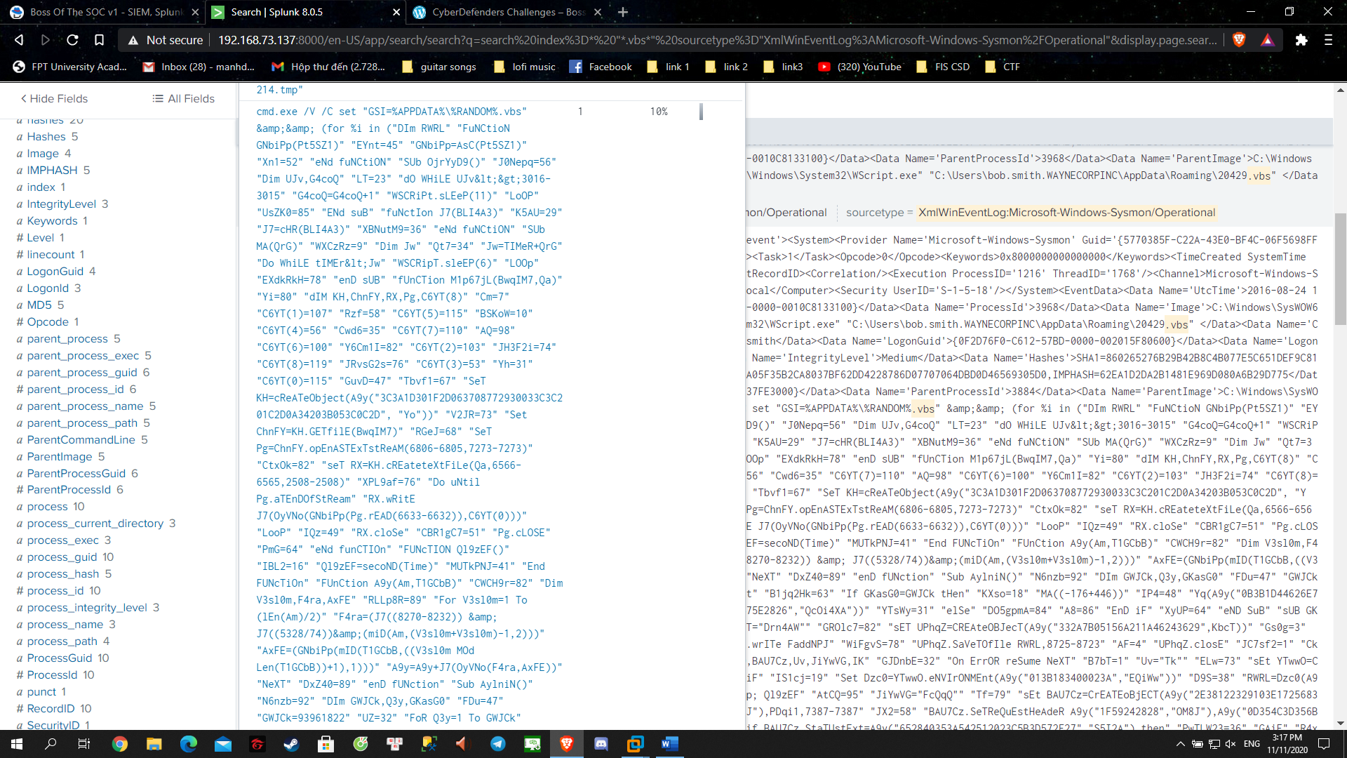

- OK, let’s make a count command:

index=* "*.vbs*" sourcetype="XmlWinEventLog:Microsoft-Windows-Sysmon/Operational"

| rex "\'CommandLine\'>(?<cmd>[^<]+)<\/Data"

| eval length = len(cmd)

| table _time, cmd, length

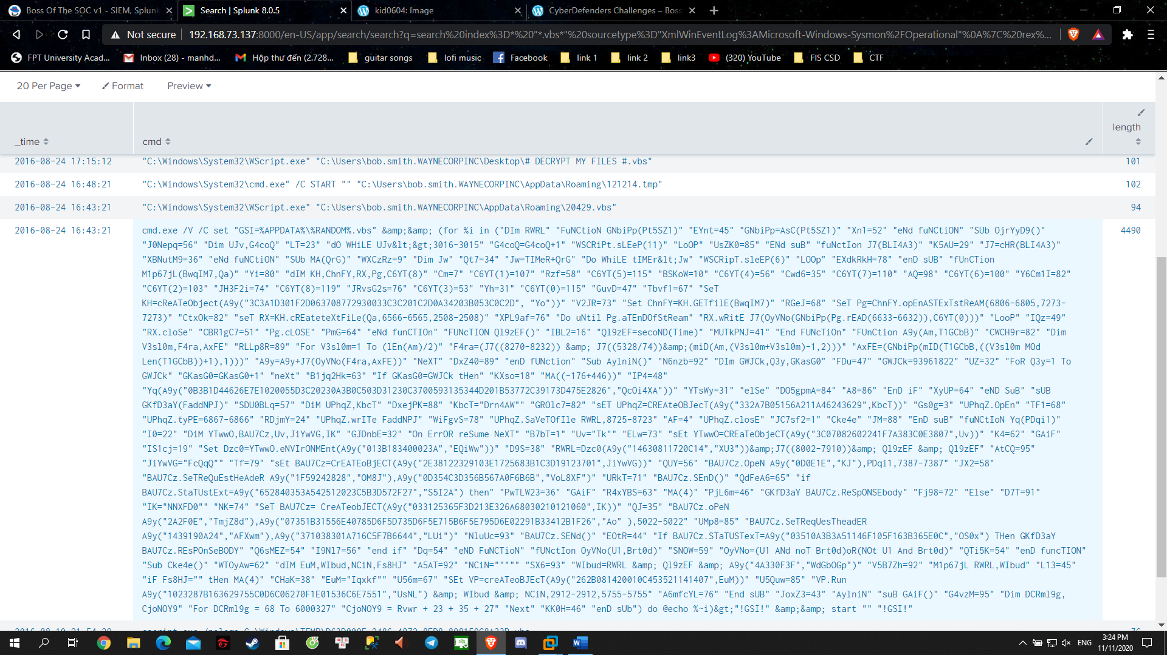

Answer: 4490

**Question 26**: What is the name of the USB key inserted by Bob Smith?

- Usually, the registry log would recould the usb plugin so let’s take a look:

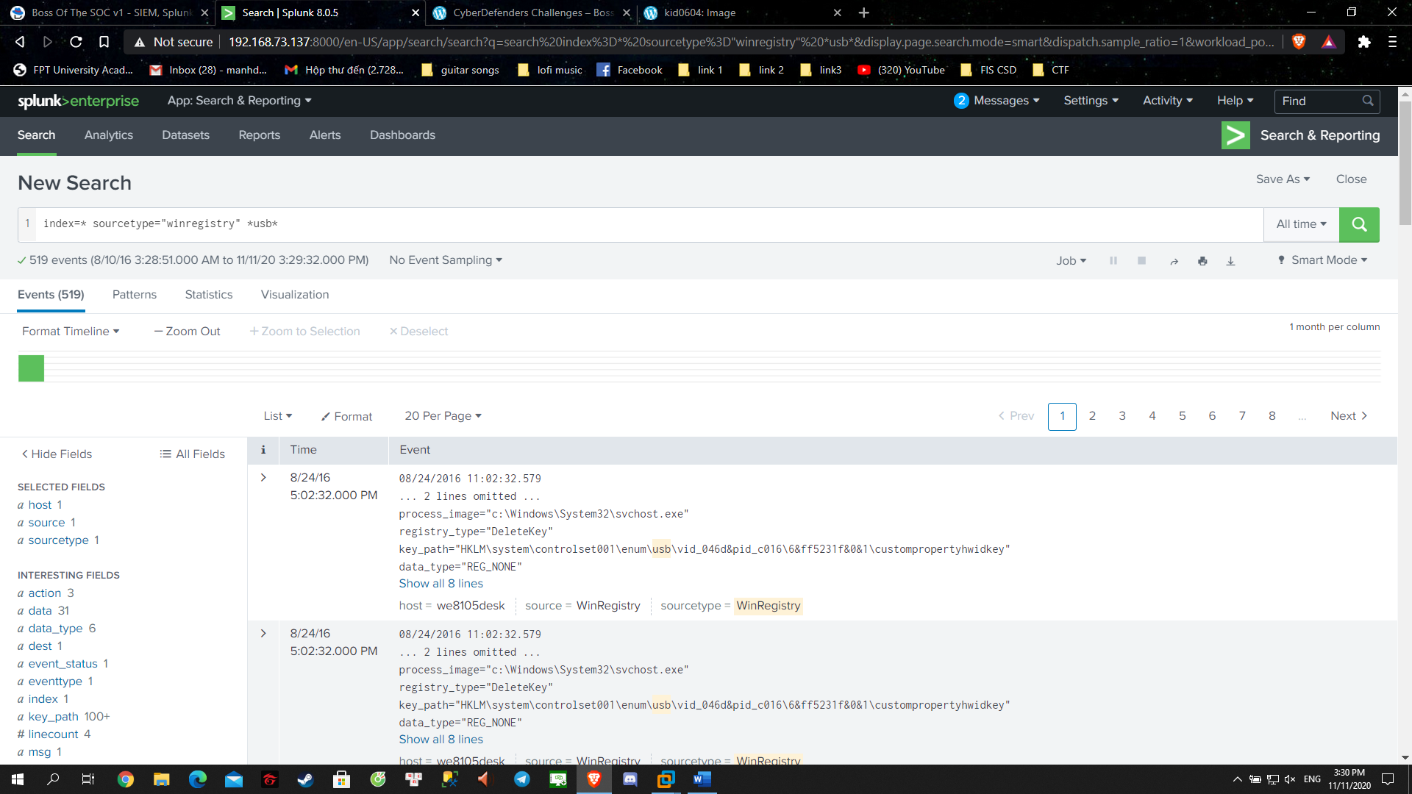

- I Got 519 events to look on …

- So I look up google how I can distinct that usb plugin out and I bump into this: <https://www.blackbagtech.com/blog/analyzing-usb-entries-in-windows-7/>

- the FriendlyName field might be the one that we can include in the search, let’s try:

index=* sourcetype="winregistry" *usb* *friendlyname*

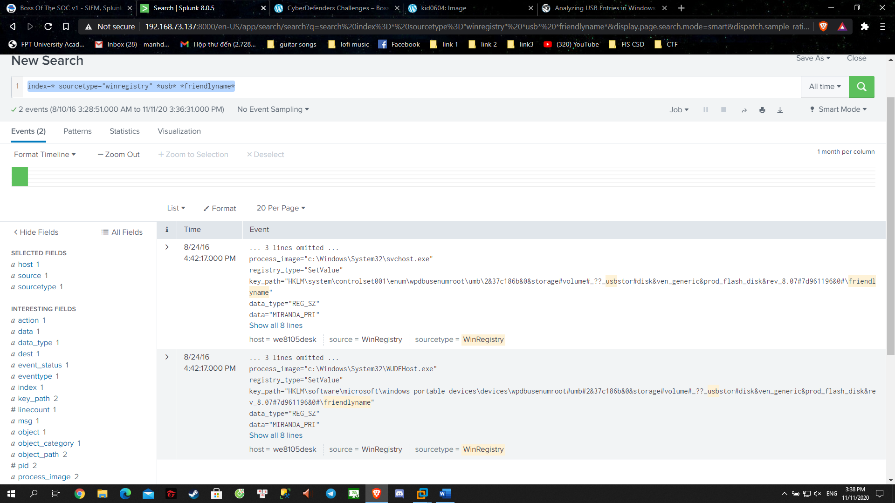

- Gotcha

Answer: MIRANDA_PRI

**Question 27**: Bob Smith's workstation (we8105desk) was connected to a file server during the ransomware outbreak. What is the IP address of the file server?

- Connecting to a file server is likely to be port 445

<https://bkhost.vn/posts/port-445-la-gi#:~:text=Port%20445%20hay%20c%E1%BB%95ng%20445,2000%2Fserver%202003%2FXP.&text=%E1%BB%9E%20tr%C3%AAn%20c%C3%A1c%20h%E1%BB%87%20%C4%91i%E1%BB%81u,TCP%2FIP%20(NetBT)>.

- As I search, it seems to be it:

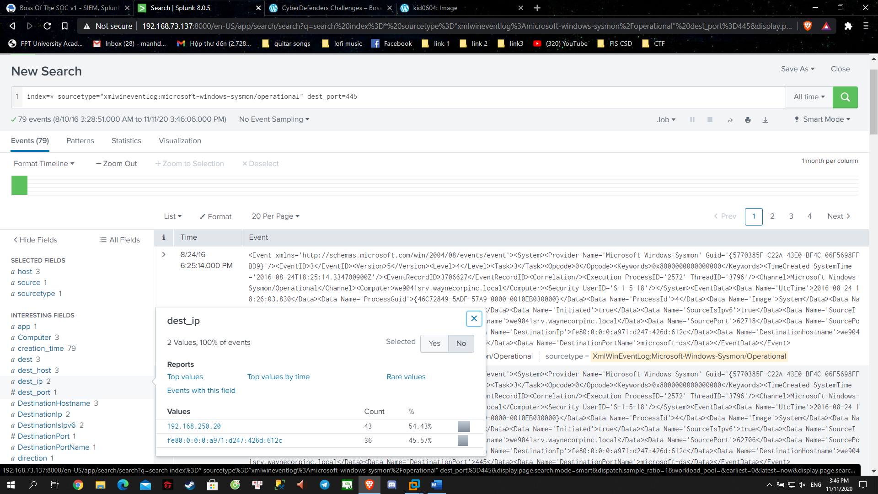

- Only got 1 option for this xD

Answers: 192.168.250.20

**Question 28**: How many distinct PDFs did the ransomware encrypt on the remote file server?

- Encryption : security log might have it

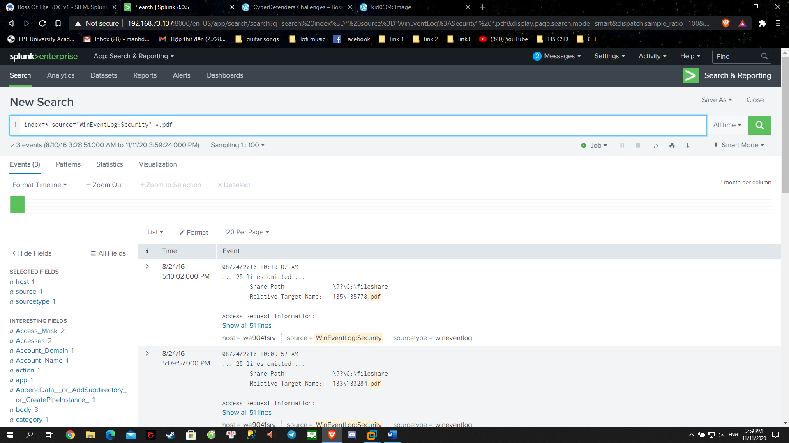

- It too few, let’s try add that field contain pdf

- Adding a single one Event_Code that we have in the previous search:

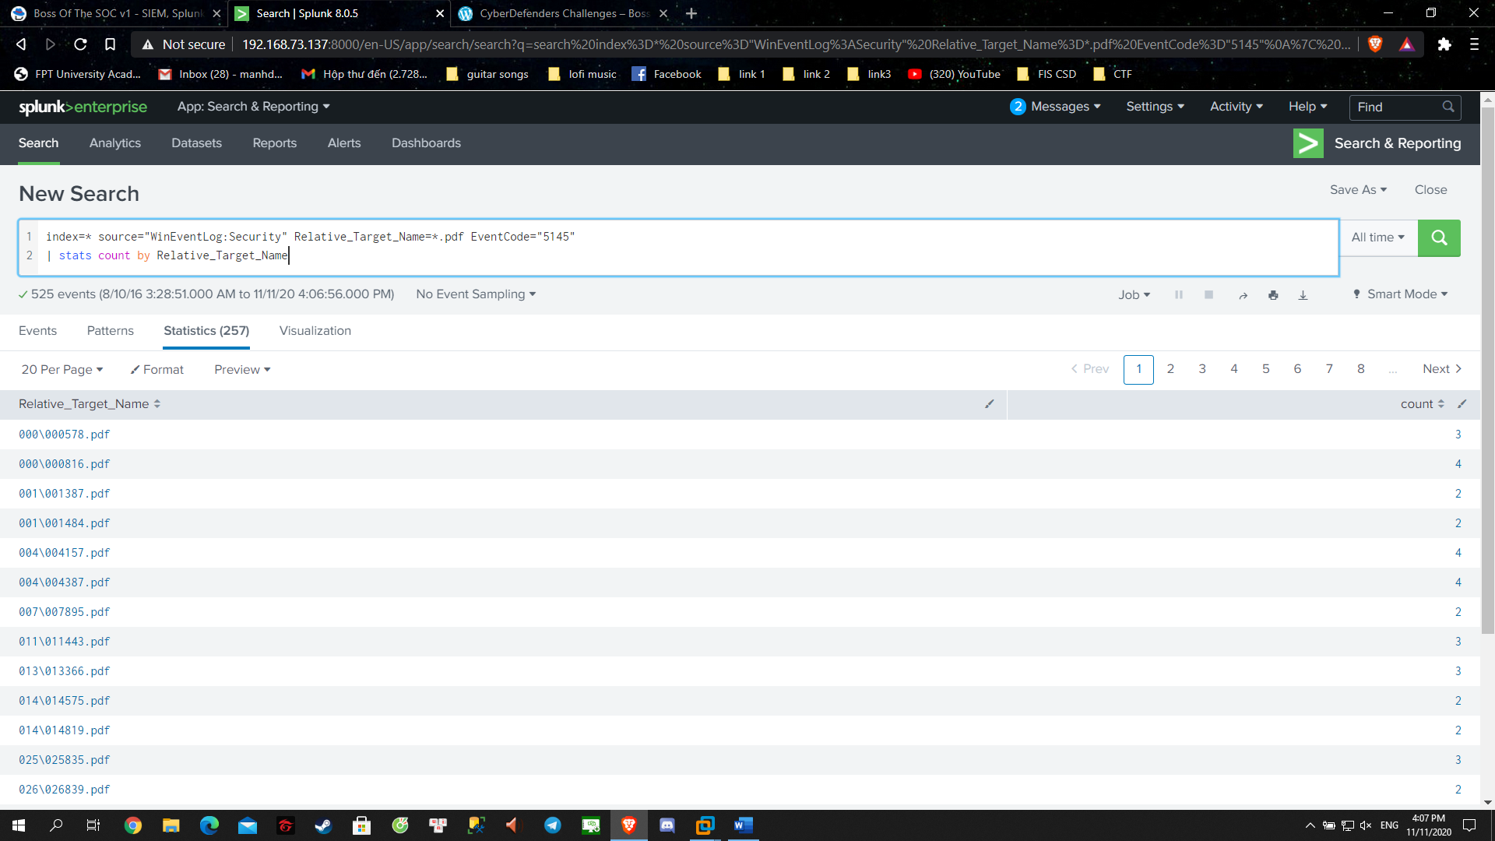

Answer: 257

**Question 29**: The VBscript found in question 25 launches 121214.tmp. What is the ParentProcessId of this initial launch?

index=* "*.vbs*" sourcetype="XmlWinEventLog:Microsoft-Windows-Sysmon/Operational"

| rex "\'CommandLine\'>(?<cmd>[^<]+)<\/Data"

| eval length = len(cmd)

| table _time, cmd, length

- Run back the command and look for the file in question

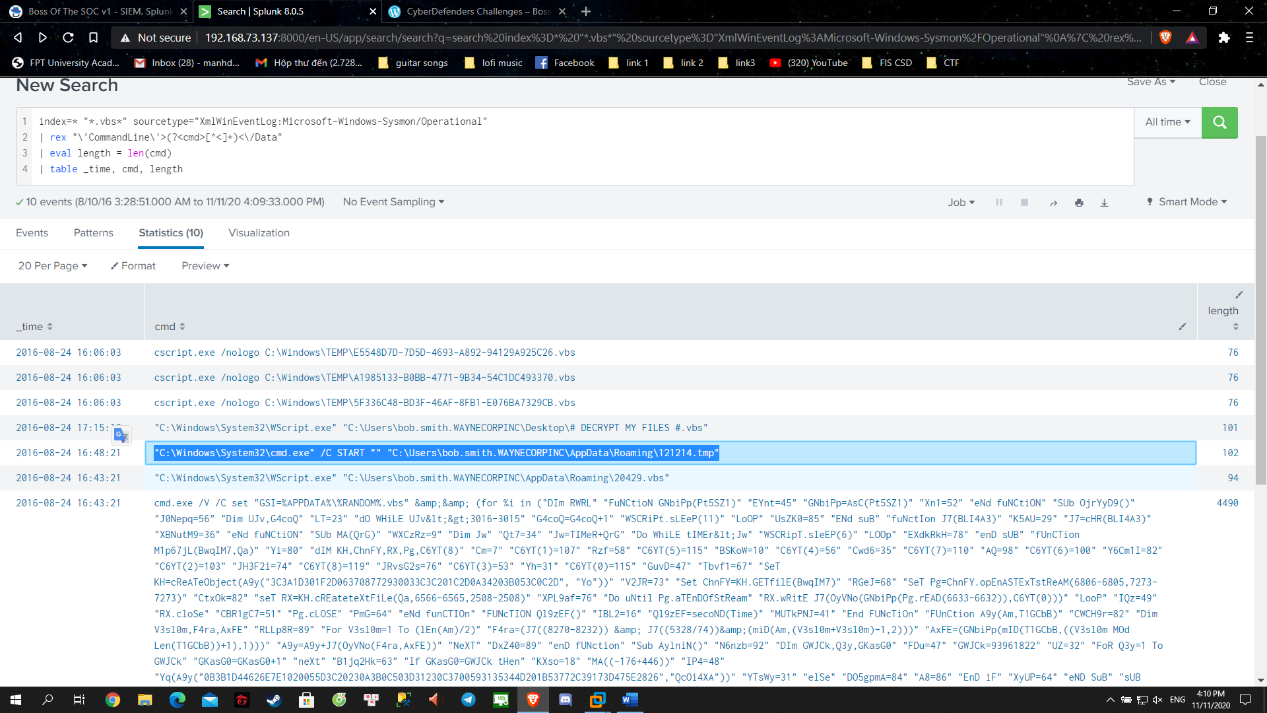

- Ok, lets view it:

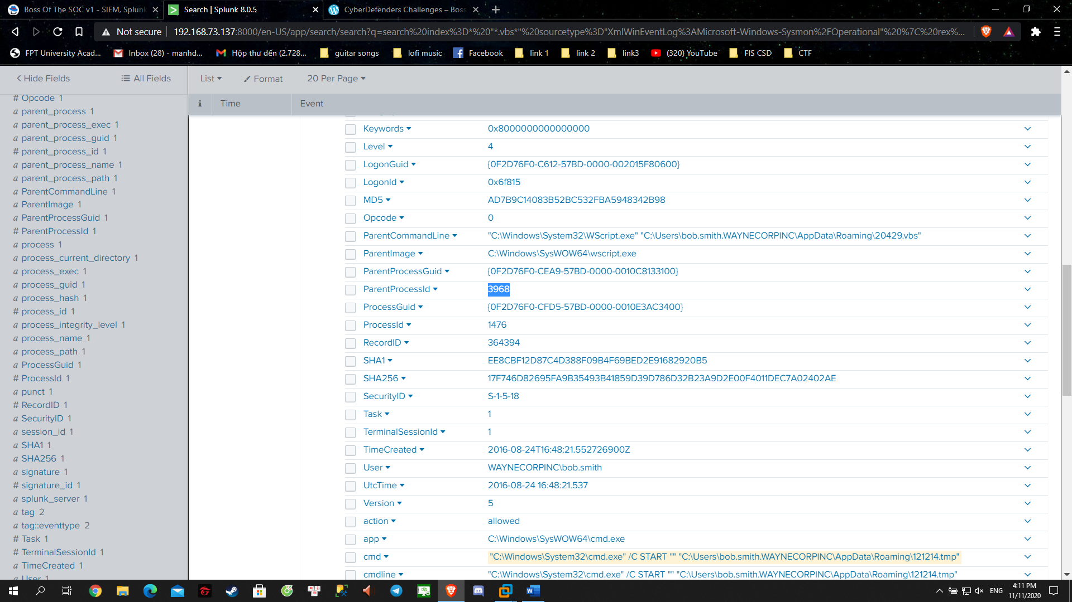

Answer: 3968

**Question 30**: The Cerber ransomware encrypts files located in Bob Smith's Windows profile. How many .txt files does it encrypt?

index=* *.txt sourcetype="XmlWinEventLog:Microsoft-Windows-Sysmon/Operational" "*C:\\Users\\bob.smith*"

| rex "\'TargetFilename\'>(?<file>[^<]+)<\/Data"

| search file="*C:\\Users\\*.txt"

| stats dc(file)

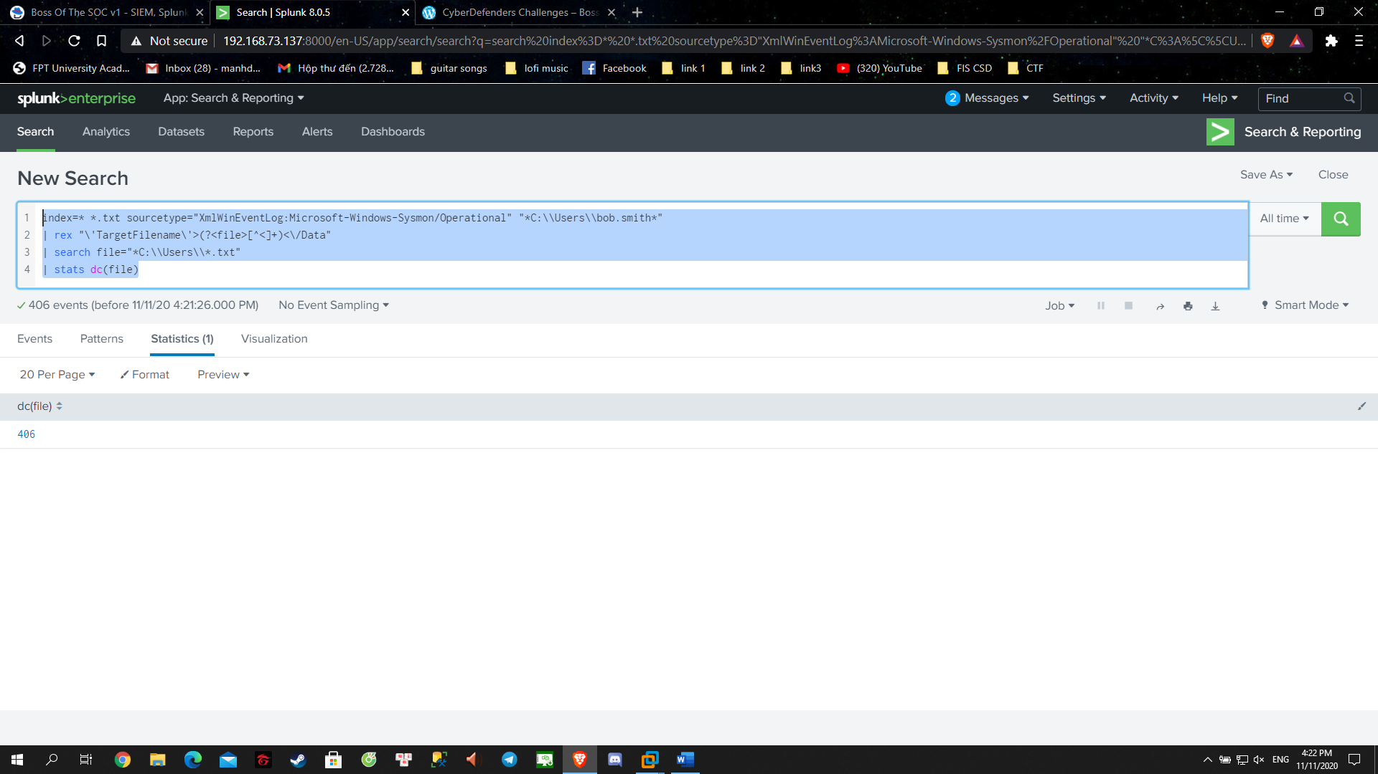

Answer: 406

**Question 31**: The malware downloads a file that contains the Cerber ransomware cryptor code. What is the name of that file?

index=* *solidaritedeproximite.org app=http

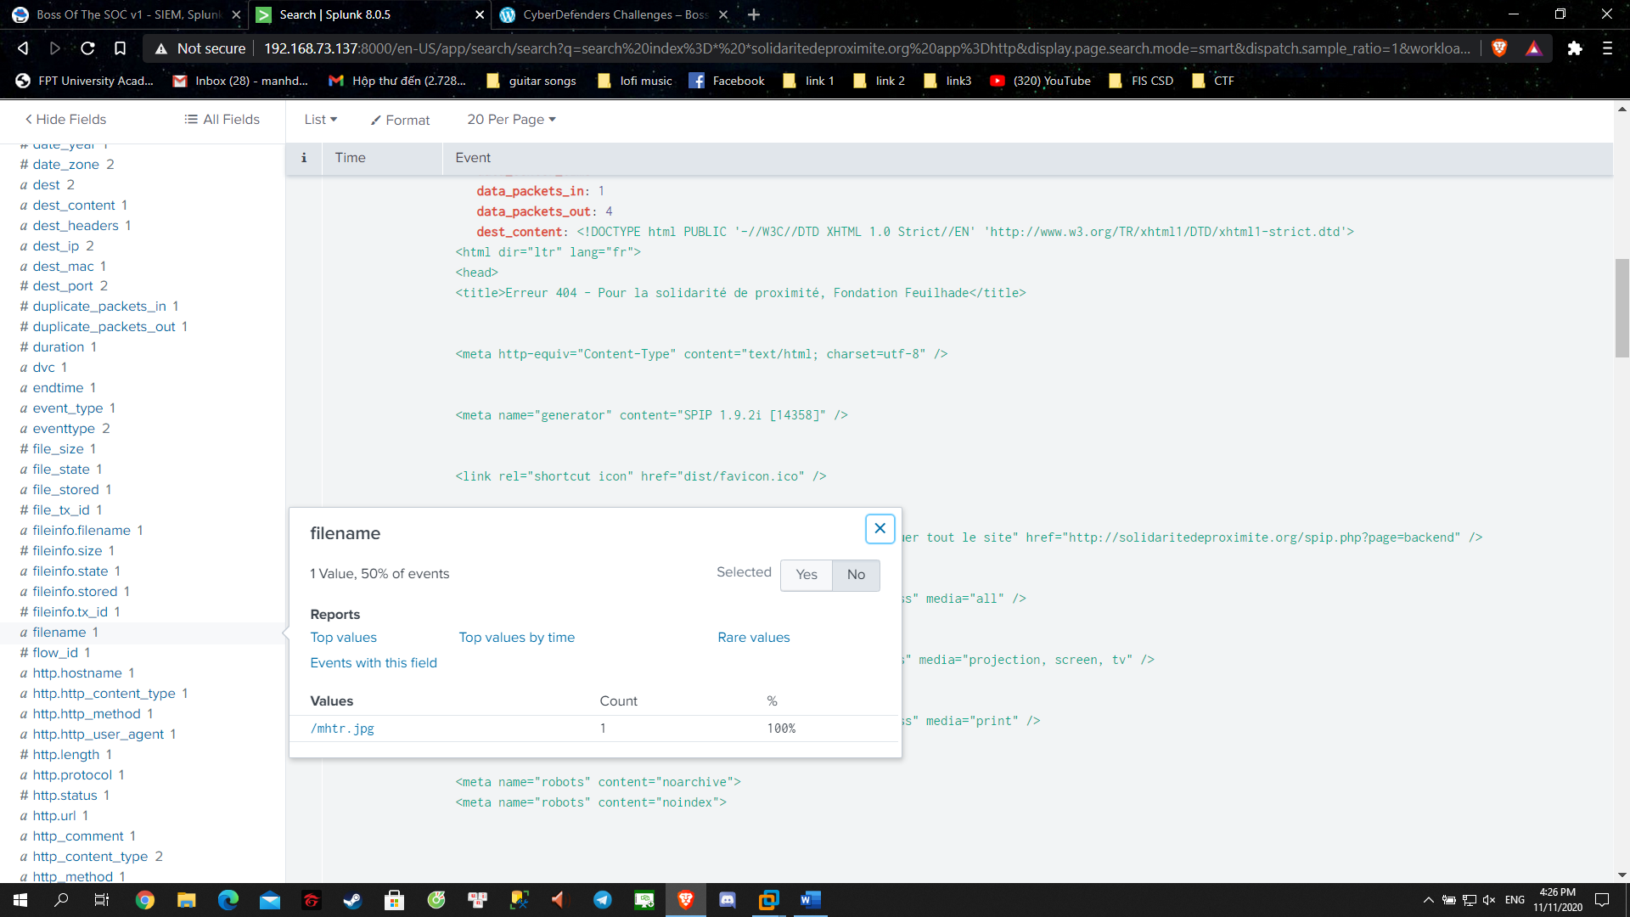

Answer: mhtr.jpg

**Question 32**: Now that you know the name of the ransomware's encryptor file, what obfuscation technique does it likely use?

Google the mhtr.jpg and I got this Steganography.